Tel. (UK) 01388 529000  Fax. (UK) 01388 526474  Mobile 07971 512279  E-Mail – hollin@globalnet.co.uk  www.hollinapplications.co.uk | The Station  Wolsingham  Bishop Auckland.  Co. Durham.  DL13 3BL England

RPM. Meter Instructions
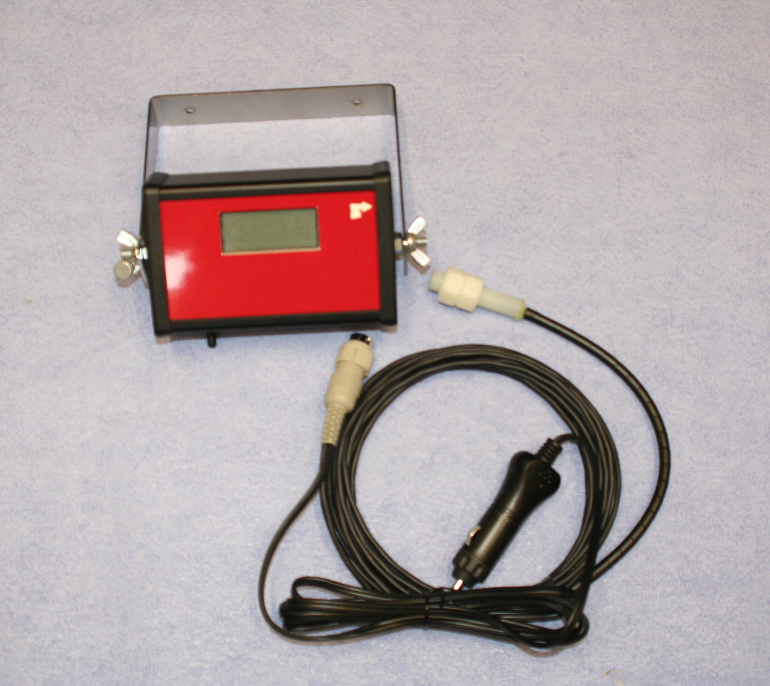

 | Technical:
 | Size | 78 x 127 x 45mm
 | Voltage | 10 to 30 volts D.C.
 | Supply | 3 m input two core cable
 |  | Reverse Polarity protected
 | Display | 4 character, 20 x 50 mm.
 |  | 15 mm Character height Backlit
 | Sensors | Magnetic reed sensors
 |  | 12mm Ø, 5m cable length.
 |  | Magnets 10mm Ø x 5mm
 | Microcomputer | ST6265 with data retention

Installation
- Mount the monitor box within the tractor cab, using the M6 bolts in a suitable position.
- Run the cable for the sensor down through the machine, avoiding trapped areas, hot areas and over stretching.
- Fit the sensor within 20mm of the rotating shaft either with a small bracket or cable ties.
- Fit the magnet to the shaft using epoxy glue. These are high intensity units preferred to the older central hole mount types. Check the magnet and sensor pass each other safely as the shaft rotates.
- Run the power cable to a suitable 12 volt source. The unit is very low power and can be fitted to a permanent supply or through the ignition.

Standard Operation
As soon as the unit has power it will show Taco (Tachometer) for 2 seconds as it does its own internal checks and for use as an identifier.

After this time the display will begin to show the revolutions per minute calculated as the magnet passes the sensor.
Unit with Low Revs. Buzzer Option
Hold the side button in when the unit is switched on. The display will show Trip for 2 seconds then the preset trip value. Press the button again to change to the desired trip level. the available range is from 0000 to 9900 RPM. At 9900 RPM the trip value will reset back to zero. After 6 seconds of the button not pressed the display will return to Taco and then the normal running mode, the new trip value is stored.

As the RPM increases up passed the trip level the monitor is armed, next time the RPM drops below the trip level the buzzer will sound continually and the external output is energised. Pressing the side button disables the buzzer but not the external output and disarms the control until the RPM rises above the trip level again.

Title | RPM Instructions | Drawn | Kim Proud
Dwg. No. | Hol4-Dwg6-029v2 | Date | 6th Dec 2013

