The Station,
Wolsingham,
Co. Durham
England.
Tel. 01388 529000
www.hollinapplications.co.uk

MONITOR INSTRUCTIONS
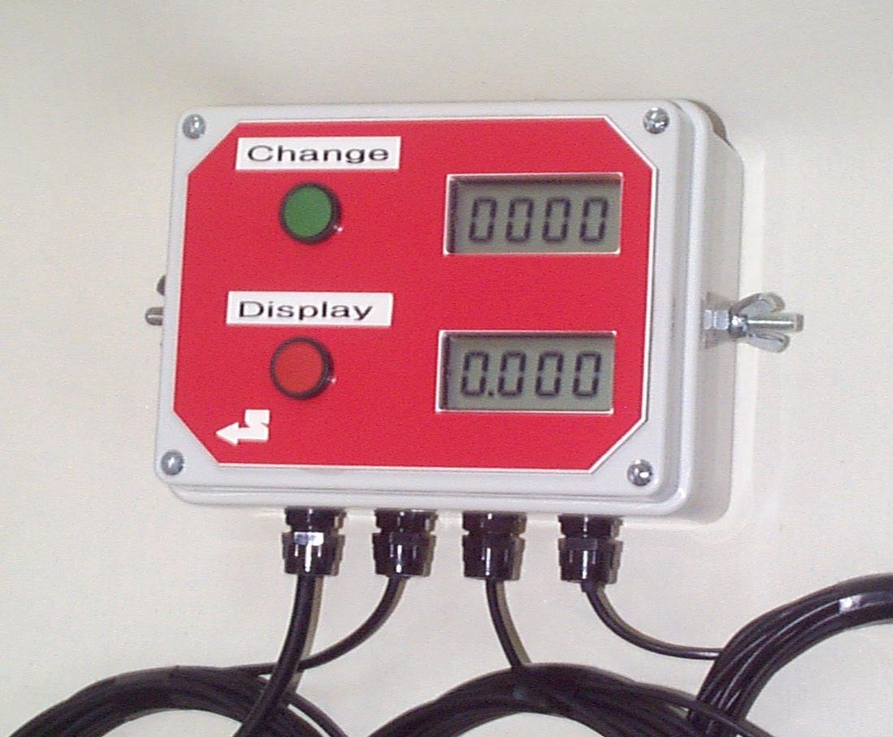

Standard Farm Monitor and Digital Seed Drill Control.

Basic Functions of:
Running Area in Acres or Hectares.
Total Area in Acres or Hectares.
Speed displayed in Kms/hour or Miles/hour
Distance Displayed in Kms.Meters
Seed Drill Tramline Control.

Contents

Introduction
Technical
Installation and Start-up
Operation

Introduction

This is a special designed control by Hollin Applications for the general use in agriculture.

Using a small magnetic reed relay sensor mounted close to the wheel or propshaft with the magnet fixed to the rotating mechanism, the unit counts the number of turns and the rotational speed of the ground wheel.

There is a second magnetic sensor or switch input which can be used to disable the area counts at headlands etc. This can be paralleled up to a pause switch if required.

The unit stores all relavent information at switch off. Two panel buttons allow for all adjustments of the functions on the large display.

Technical

Power supply - DC 10 to 30 Volts low current.
Fused - not applicable
Dimensions - 6” * 4” * 2 1/2”
Display - 4 character, some alphanumeric
- Optional backlight.
Magnetic Reed Sensor - M12 nylon, 40mm length, 2 mounting nuts.
- Protection fitted to the wheel sensor.
- Working distance to magnet 10 to 25mm
Circuit board - Standard Monitor unit – ST6265 Processor 8MHz
- Memory retention of Count and options
Wiring

Pin.1 Yellow Sensor Input Positive. Red Wire
Pin.2 Blue Sensor Input Ground. Blue Wire
Pin.3 White Output Signal Ground.
Pin.4 Green Output Signal 12 volts on tramline lane.
Pin.5 Brown Not Connected, Optional Actuator output
Pin 6 Red Not Connected, Optional Actuator output
Pin 7 Black Ground Output

Installation

Mount the control box within the cab so that the display can be easily seen. Position using a suitable bracket and the side mount M6 bolt fixings.

With the control switched off run the power cable to a suitable 12 volt dc power source. This must have permanent power and not be switched through the ignition or data may be lost at power off. Brown or red core for positive and blue or black for negative. The control is reverse polarity protected.

Run the wheel sensor cable, identified with the protection sleave,and the W mark, down through the cab to a suitable position on the axle of the wheel. Fashion a bracket to mount the wheel sensor with ½ inch hole or cable tie the sensor in a suitable position. Mount the powerful linear magnet onto the wheel hub with a suitable epoxy glue. Check that the magnet will not catch the sensor and will pass within 10 mm of the sensor.

Run the machine cut off sensor cable, identified as the sensor without the protection sleeve down to a position where the machine will move at headlands. When the magnet is close to this sensor the area counters are disabled, but the speed displays are still enabled, the Seed Drill Control will increase by 1. There are many possibilities for positioning this sensor,
- Lever movements within the cab,
- Three point linkage movements at the headlands,
- Arm movements on the machine.
- Cut the sensor off and fit to spare terminals on a spray cut-off switch
- Short circuit to dissable the area count.
Check again that the sensor comes within 25mm of the magnet when the unit moves.

Circumference and Width measurements.

In the start up procedure the control allows for the input of the wheel circumference and the width of the machine.

Circumference, the measurement required is actually the distance the machine moves between each pass of the sensor.
For the magnet fitted to the wheel.
- mark the ground and the wheel.
- drive in a straight line with a second person counting the number of wheel turns. Stop at ten turns precisely.
- Measure the distance travelled and divide by ten.
- Keep a record of this value for future reference.

Width is input as span of the machine, to 25.6 m maximum

Start-Up

After power on the control displays Area for 2 seconds.
During this time the control performs its own self tests.
During this period it is also possible for the user to switch
To Options mode.

DISPLAY
CHANGE
Pressing Change and Display buttons at the same
time,whilst the control is in the initial test mode
enters the option change mode.

Initially Circ for Circumference is displayed for 2 seconds

CHANGE

Press change to increase the circumference to the
value required. Note the maximum circumference
is 5.12 metes, always displayed in meters ie 5m12cm
Press and hold will increment automatically.
DISPLAY
Press display once to store the new circumference and
Move on to input the span of the machine.

CHANGE
Press change to increase the machine span to the
value required. Note the maximum machine width
is 25.6 meters, always displayed in meters ie 25m60cm
Press and hold will increment automatically.
DISPLAY

Press display once to store the new span value and
Move on to the operational mode.

CHANGE
Press change to increase the machine span to the
value required. Note the maximum machine width
is 25.6 meters, always displayed in meters ie 25m60cm
Press and hold will increment automatically.
DISPLAY
Press display once revert to the operational mode.

Operational Mode

After the initial 2 second display of area the control will always switch to display the identifier for the last Mode i.e. if switched off in distance then on in distance.

There are seven displayed modes of operation. These are swapped sequentially with each press of the display button. Holding the button displays a character sequence as an identifier. Press and hold the change button to reset the area and distance counts.

Running Hectare and Acre Display
Displays an accurate running Hectare Area covered.
The smallest denomination displayed is 0.001 Hectares ie 10 m2.
CHANGE
Press and hold change to clear the running Area store.
Note this also clears the running Acre display

DISPLAY
Press display once to convert to show in Acres.

Total Hectare and Acre Display
Press Display again to change to the total or machine area displays
Displays an accurate running Hectare Area covered.
The smallest denomination displayed is 0.001 Hectares ie 10 m2.
CHANGE
Press and hold change to clear the running Area store.
Note this also clears the running Acre display

DISPLAY
DISPLAY
Press display once to convert to show in Acres.

Two Speed Displays

Press Display again to change to the speed displays
Displays an accurate running ground speed.

Initially displays SP:EU for european measurements and displays
Ground speed in Km’s per hour

DISPLAY
DISPLAY
Press display once to convert to show in Miles/hour.
Initial shown by SP:GB

Speed Display is updated every 2 seconds.
If there are no pulses for 10 seconds then the display will clear.

Display Distance in Kilometers and Meters.
Press Display again to change to the Dsitance displays
Displays an accurate running Distance covered.
The smallest denomination displayed is 0.001 Kms or 1 m.

DISPLAY
DISPLAY
Press and hold change to clear the Distance store.

Press display again to revert to running area.

Top Display Shows Required and Actual Lane Counts.

The top display shows the required number of lanes on the
Right and the actual lane on the Left.
Each headland the lane count will increase by one.

When the lane count equals the required tramline count the
Control will output 12 volts for the clutches/solenoid seed
Cut-off systems.
The buzzer will sound for 10 seconds.
The display will flash all the time in the tramline lane.

The switch on the right side of the control for normal operation that is count signals from the machine headland sensor is in the up position.
Press the switch to the centre to disable the input count from the headland sensor, this can be useful when avoiding obstacles in fields etc.
Flick the switch up to manually input a headland count, useful for starting the field at a set count etc.

Other Controls From Hollin Applications

Hollin Applications pride themselves in a flexible approach to customers requirements, and are always willing to listen to your opinions and help. This approach is lead us to have an increasing range of controls for Agriculture.

Areameter Kits with Speed Alarms

Seed Drill Tramline Control

RPM Shaft Rate Monitor

Simple Number Counters

Low Cost Digital Temperature units

Bale Wrap Monitors

We also distribute Warner Electric Linear Actuators.

Controls for Linear Actuators

Position Displays for Spreader Systems.

Automatic Gate Systems

Hollin Applications,
The Station
Wolsingham,
Co. Durham, DL13 3BL
Tel./Fax. 01388 529000
Web. www.linearactuators.co.uk

Feb 2004

