‘The Station’
Wolsingham
Co.Durham
DL13 3BL
Tel 01388 529000
Fax 01388 526474
hollin@globalnet.co.uk
www.hollinapplications.co.uk

Hollin
Applications Ltd

BALE WRAP MONITOR INSTRUCTIONS
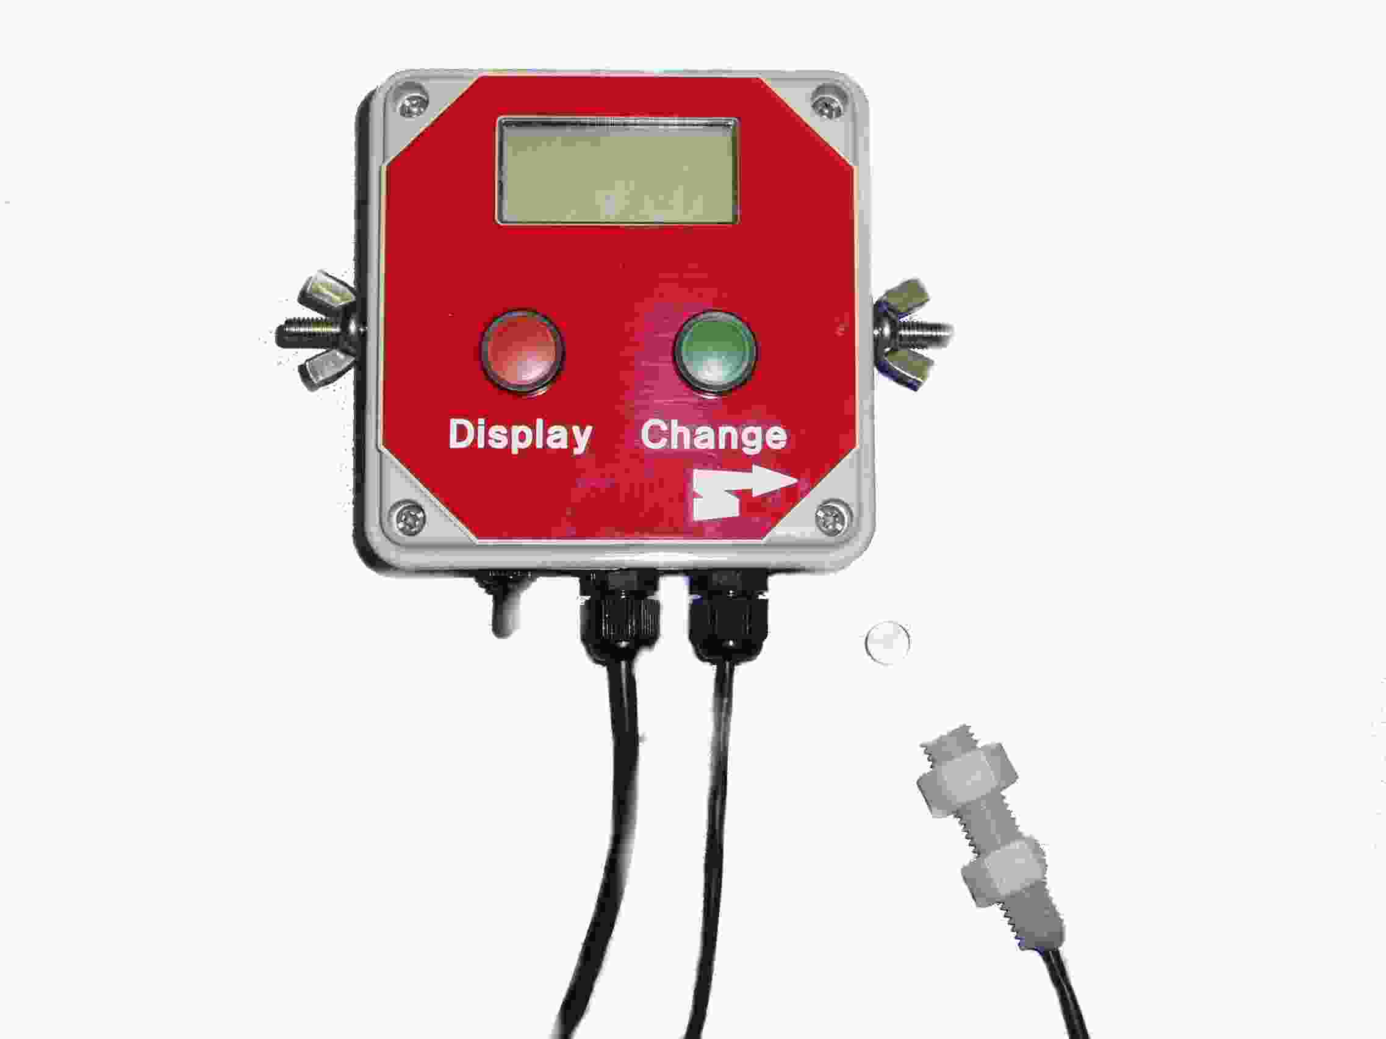

Hollin Applications Standard Bale Wrap Monitor

Basic Functions of:
Count number of turns of rotator.
Internal and External Alarm.
Running and Total Bale Counts.

Contents

Introduction
Technical
Installation and Start-up
Operation
Wiring
Modifications or options.

Introduction

This is a standard designed control by Hollin Applications for the general use in agriculture, and will work with most manufacturers machines.

Using a small magnetic reed relay sensor mounted close to the spinning bar and the magnet fixed to the rotating mechanism. The unit counts each time the bar passes and compares it against a preset count figure. The Alarm will sound when the count is within 2 of the preset figure.

There is an option for an external 12 volt output for larger sounders or alarm lights.

The unit stores all relavent information at switch off.

Two panel buttons allow for all adjustments of the functions on the large backlit display.

Technical

Power supply - DC 10 to 30 Volts low current.
Fused - not applicable
Dimensions - 6” * 4” * 21/2”
Display - 4 character, some alphanumeric
- Optional backlight.
Magnetic Reed Sensor - M12 nylon, 40mm length
- Working distance to magnet 10 to 25mm
Circuit board - Standard Monitor unit – ST6265 Processor 8MHz
- Memory retention of Count and options
Protection - IP56. Rain and weather proof.

Installation

The unit can be mounted within the tractor cab or external next to the wrapping machine. The control is weather and rain proof at IP56 but do not directly pressure wash the control.
Mount using the provided side bolts and wing nuts or through the rear panel of the control box.

With the control switched off run the power cable to a suitable 12 volt dc power source. This must have permanent power and not be switched through the ignition or data may be lost at power off. Brown or red core for positive and blue or black for negative. The control is reverse polarity protected.

Run the machine spin sensor cable, identified with the protection sleave, down through the cab to a suitable position near the rotating part of the machine. Mount the powerful linear magnet onto the wheel hub with a suitable epoxy glue. Check that the magnet will not catch the sensor and will pass within 25mm of the sensor.

Start-Up

After power on the control displays Wrap for 3 seconds.
During this time the control performs its own self tests.
During this period it is also possible for the user to switch
To Options mode.

DISPLAY
CHANGE
Pressing Change and Display buttons at the same
time, whilst the control is in the initial test mode
enters the option change mode.

CHANGE
Press change to increase the number of counts
required. Note the maximum number at present is 40
and the minimum 2. Press the change button until the
required count is reached. Eg. Wraps 24.
DISPLAY

Press display once to return to the running mode.
Wrap will again be displayed for 3 seconds.

Operational Mode

After the 3 second test sequences has elapsed the display will
display the number of wraps on the left then colon and the preset
number of wraps. As the magnet passes the sensor the left hand
number will increment.

When the count reaches 2 less than the intend number of wraps the
buzzer will start to sound and the external 12 volt supply will
engage. This is as a warning to be prepared to stop the wrapping.

At an equal number of wraps and intended wraps STOP is displayed
for 3 seconds before reverting back to zero for the next bale.

At any point press the CHANGE button to reset
the wrap counter

DISPLAY

Press display will show Bale whilst pressed then
display the running bale count
CHANGE

Press change to clear the bale count.
DISPLAY

Press and hold DISPLAY to show the Total Bale
Count.

DISPLAY
CHANGE

Press CHANGE and DISPLAY together to clear the
Total Bale count.
Release the buttons to revert to the running Display.

NB// Always switch the control off using the panel switch as this confirms the data retenion sequence. Data will be lost if the control is disconnected from the supply.

