Automatic Gate Instructions

Version 5 – J.Proud July 2013

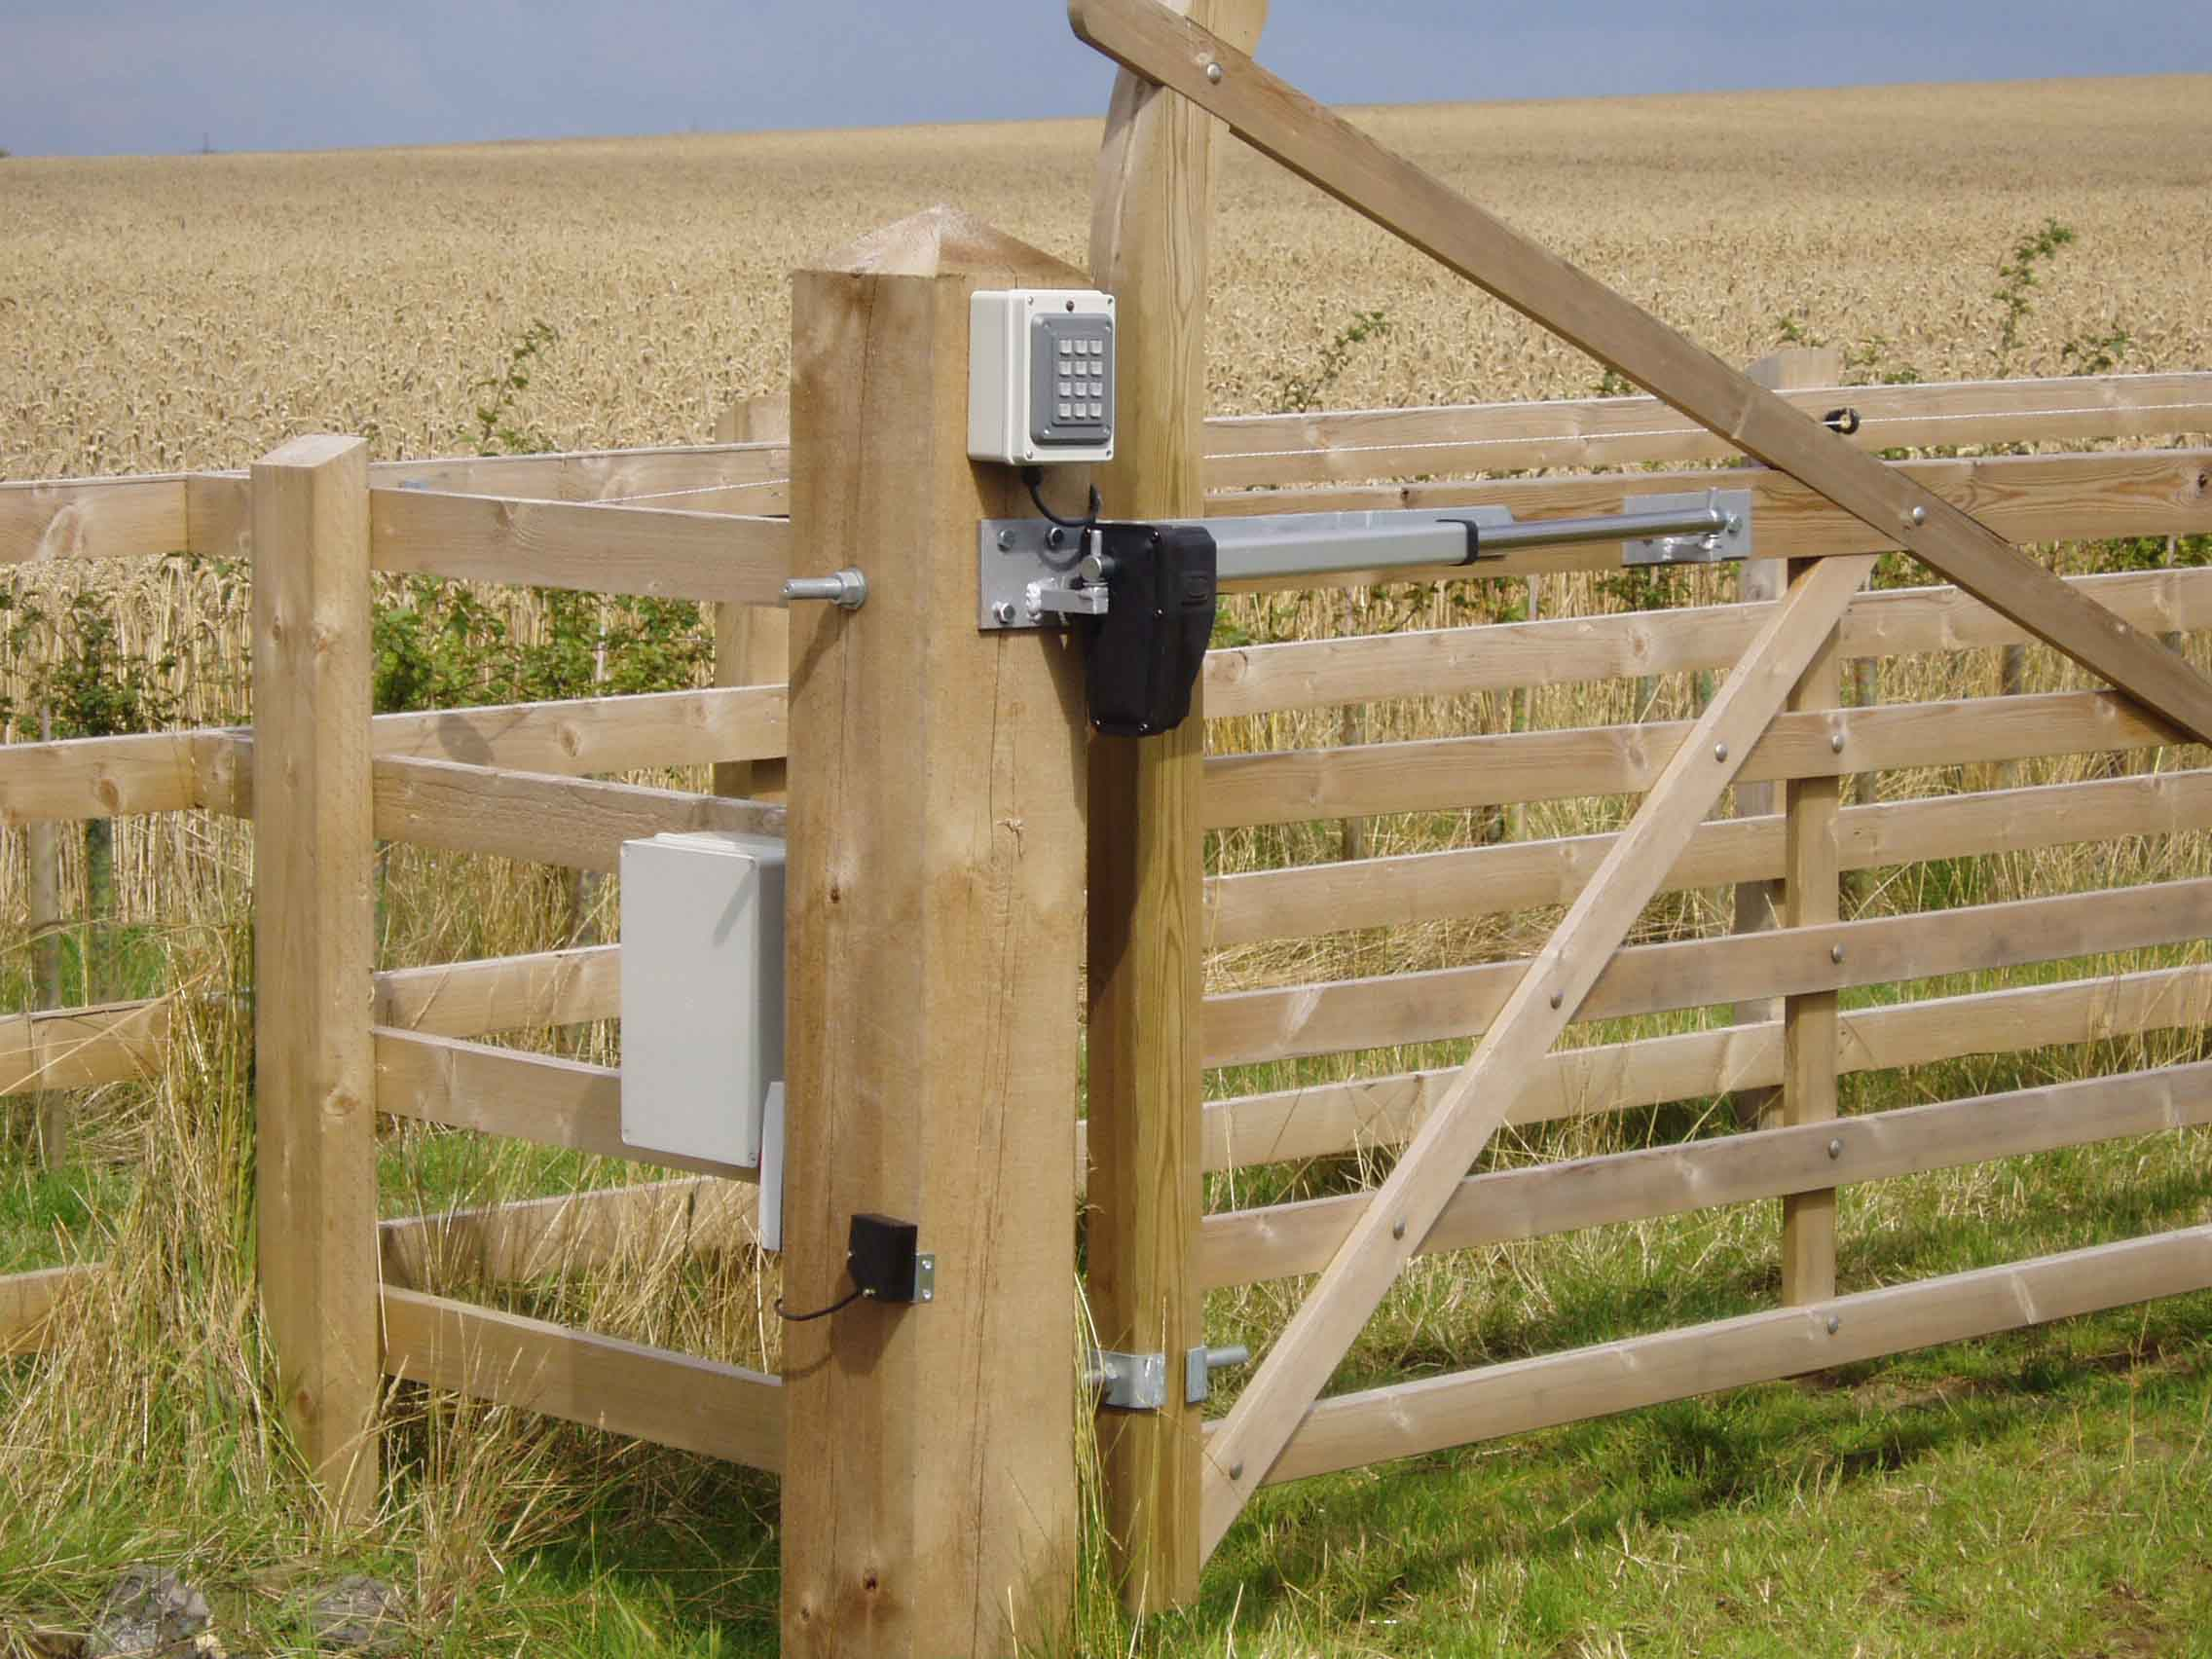

Hollin Applications, have designed this control to remotely operate a gate using a Danaher Thomson Industrial Linear Actuator.

Thomson Actuators are strong and reliable giving enhanced function over other gate systems. The Hollin kit has basic function and is specifically targeted at Agricultural or engineering end user where there is some basic knowledge for fitting and fixtures.

The Basic Control Kit consists of a 12 volt battery box with either a solar or mains powered charger. Experience has shown that the solar powered units are good for around ten operations per day in the winter months, but this of course depends on loading on the gate and sighting of the solar panel. Mains charged units use a 3 stage charger which will keep the battery in good condition no matter the current draw. DC actuators give a lower cost option with better environmental protection and higher power for weight ratio, they are also considerably safer.

The control kit also includes a basic control circuit to drive the Actuator and decode all the options. Kits always come with 2 radio keyfobs for opening and closing the gate.

These instructions include all the possible options, please ignore the pages not appertaining to your gate.
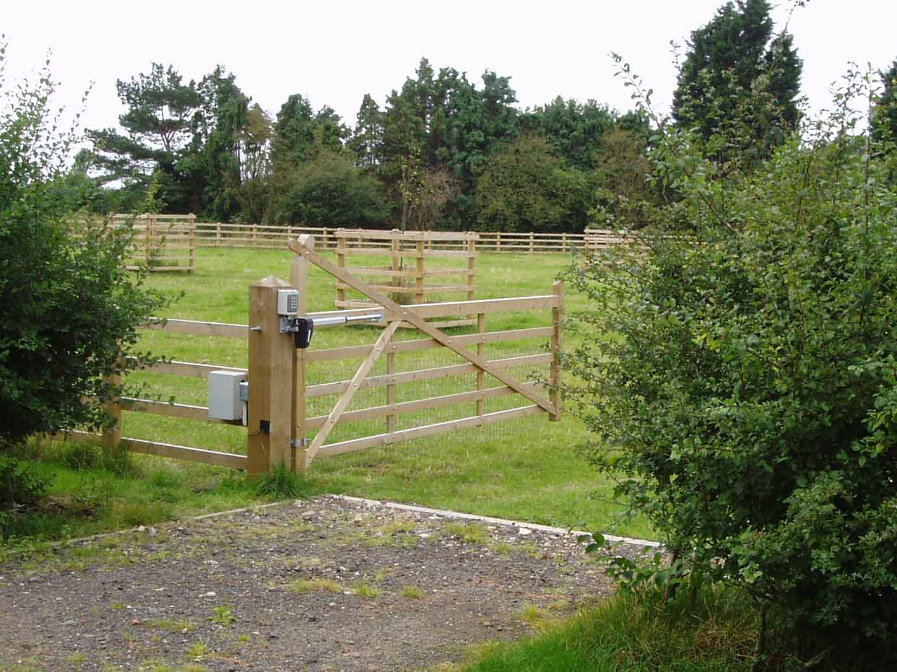

Mounting.

The Control box should be mounted on the gatepost at a height off the ground in excess of 1 meter. The higher the greater the range from the RF key fob.

It should be mounted with the aerial at the top.

Mains powered units should be connected to power with a suitable watertight container and ECB. The unit will charge from 120 -240 Volt AC.

Solar panels should be mounted using the bracket provided facing south at a rough angle of 45 degrees. Try and avoid any areas which may have some shade during the day. A regular wipe of the panel will improve its performance and life.

Mounting the Actuator.

The gate system has a choice of three Actuators.

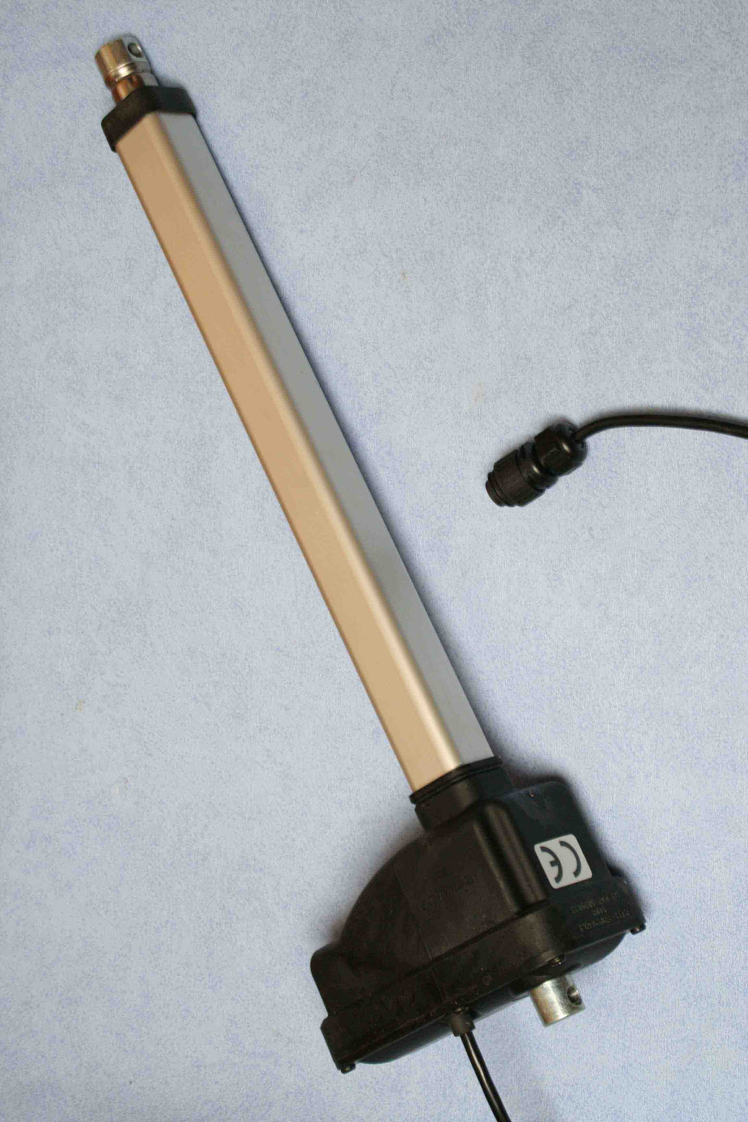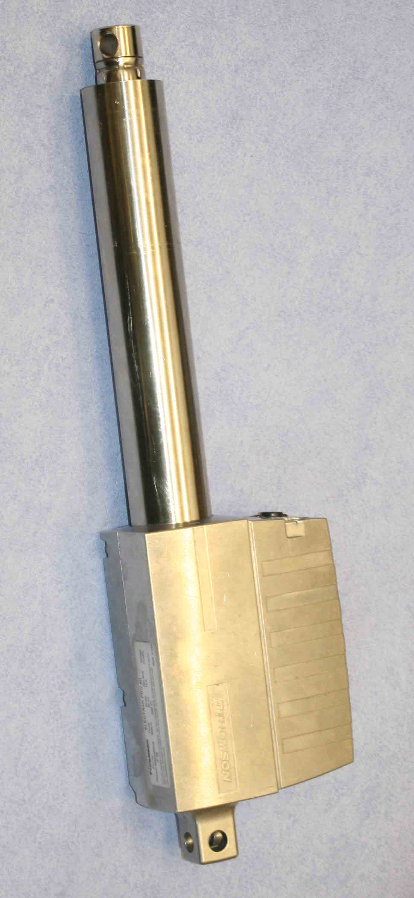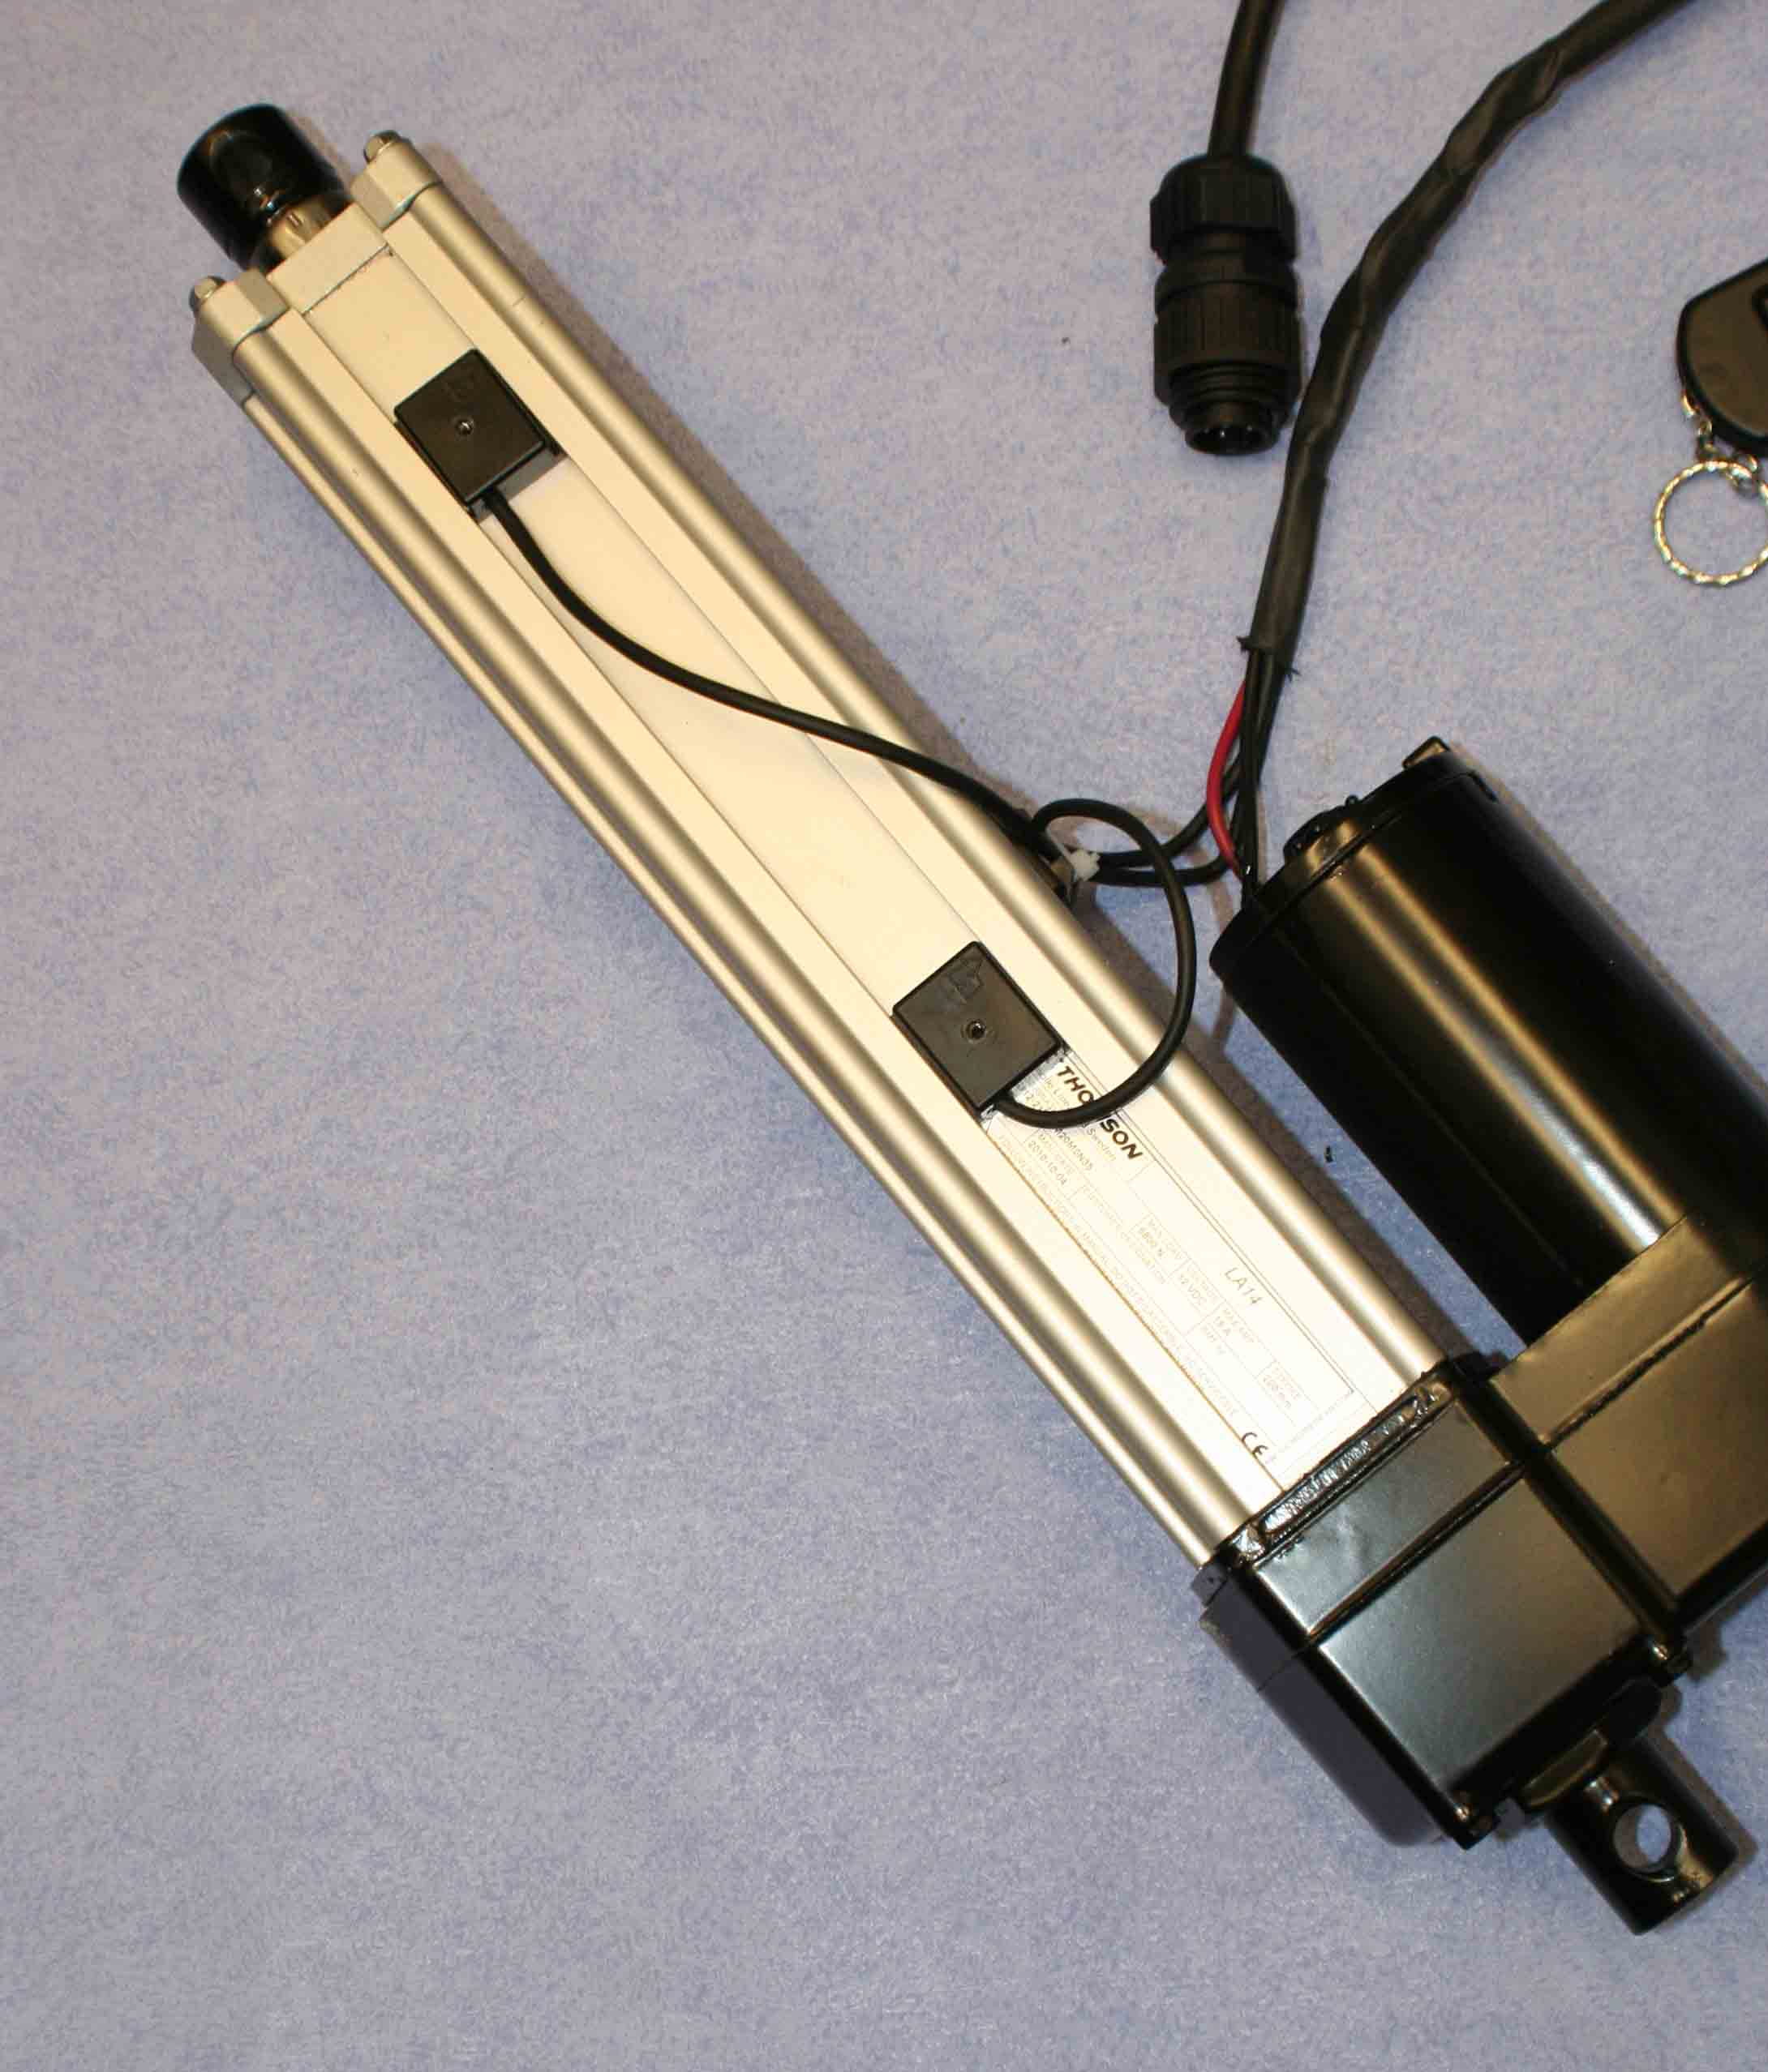

Standard Unit | Medium Range | High Power System
E150 | Pro-Series | LA14

For all units,

The rear housing of the Actuator has a stronger mechanical advantage if placed at an angle to the close gate.

Many times we have looked at how to fix the mount points and Appendix A shows how to set up the optimum point for strength of the gate. Try and set the Actuator hinge point as far out and back away from the gate as possible.

See the following pages for each different system fitting procedure.

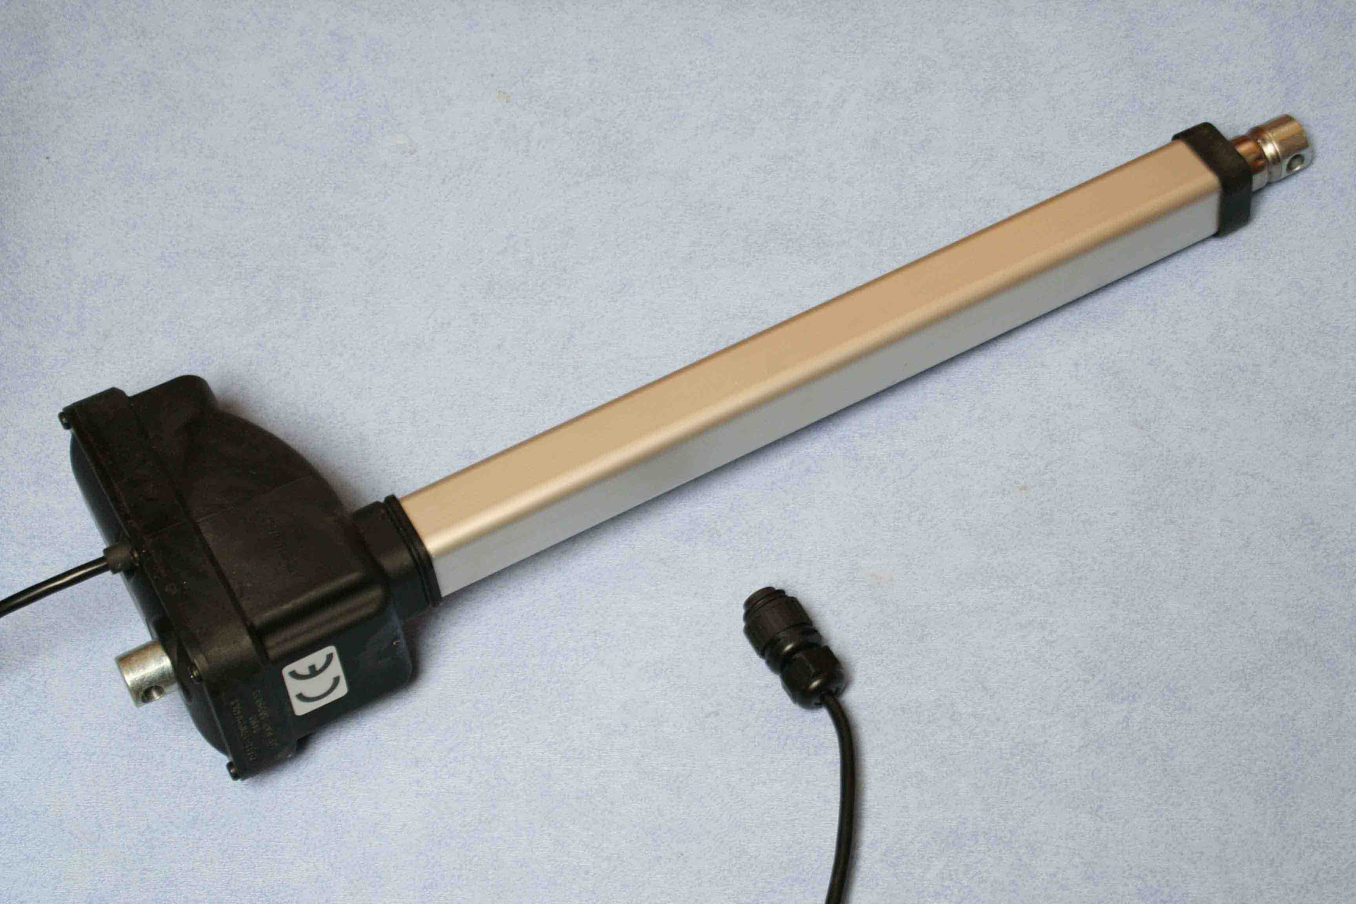

Standard Unit E150

Push and Pull of 200Kg load, adjustable limit switches. 12 volt dc motor.
Well suited to lighter wooden gates and smaller metal ones. Easier to fit as the adjustable limit switches allow for precise setting of end of stroke switch off.

Two brackets should be designed to locate the Actuator onto the gate.
For the E150 Actuator, Pivot pins of 10mm should be used. Make sure the Actuator can freely rotate on the mount pins, sleeving may be a good option. Any stiffness may cause damage.

The Actuator has a maximum retract length of 603mm and maximum extend length of 1003mm.

Once an Actuator mount point has been set.
- In the close position measure a distance from the mount to the gate of 1m and mark the gate.
- In the open position measure a distance from the mount to the gate of 600m and mark the gate.
- Fit the extension mount onto the gate between these points.

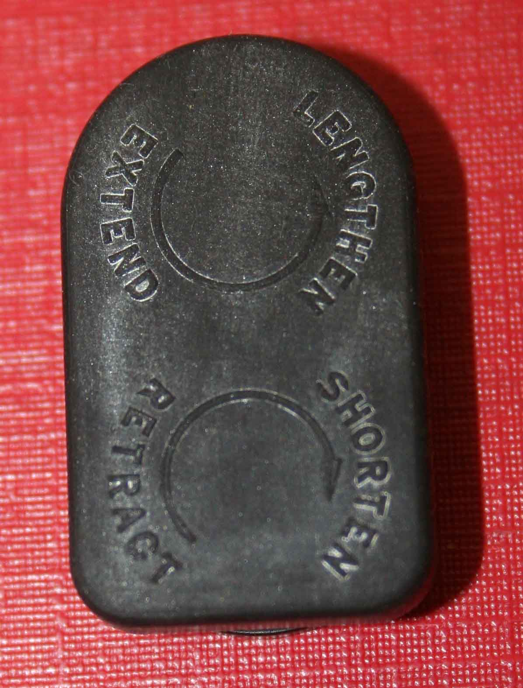
The stroke can be adjusted on the E150 actuator by turning the adjust screws on the side of the Actuator. The rubber cover which pulls out on the side of the unit identifies which way to turn each screw to adjust the limits.

Be careful not to adjust the limits beyond the mechanical limits of Actuator or system as this will stall the Actuator.

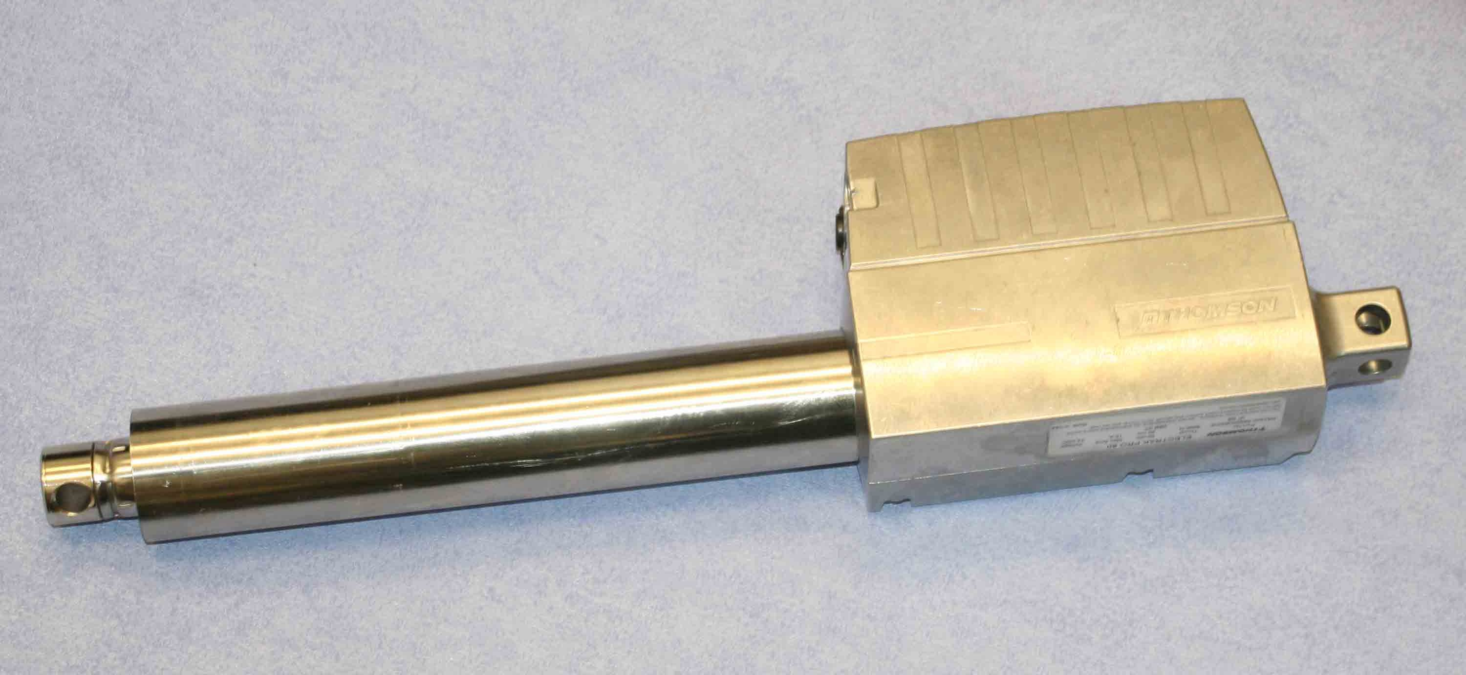

Pro-Series

Push and Pull of 250Kg load, no limit switches but end of stroke cut-out. 12 volt dc motor. As this actuator needs to jam or stall at ends of travel it requires stronger mounts than the E150 unit and is well suited to smaller metal gates. With careful fitting it can be used on conventional wooden gates where it is set up to jam at its own ends of stroke, see (2) below.

Two brackets should be designed to locate the Actuator onto the gate.
For the Pro-Series Actuator, Pivot pins of 12mm should be used. Make sure the Actuator can freely rotate on the mount pins, sleeving may be a good option. Any stiffness may cause damage.

The Actuator has a minimum retract length of 640 mm and maximum extend length of 1040 mm.
If you consider your brackets and gate strong enough to stop the Actuator at end of stroke (approx.. 300Kg) then follow procedure one else follow two, which uses the Actuators own end of stroke mechanics.

1) Once an Actuator mount point has been set.
- In the close position measure a distance from the mount to the gate of 1m and mark the gate.
- In the open position measure a distance from the mount to the gate of 600m and mark the gate.
- Fit the extension mount onto the gate between these points.

2) Place a mark on the gate somewhere between 640 and 1040 out from the hinge point. Eg 840mm
- Then in the open position using a tape 640 long make an arc from the mount point.
- Then in the closed position using a tape 1040 long make a mark where this arc crosses the open one.
- This point is exactly where the actuator rear mount should be.

For both methods-
- The Actuator should drive out to close the gate and jam at the closed point.
- Internal circuitry will sense that the Actuator has stopped and automatically switch it off.
- This also happens as it retracts in the open position.
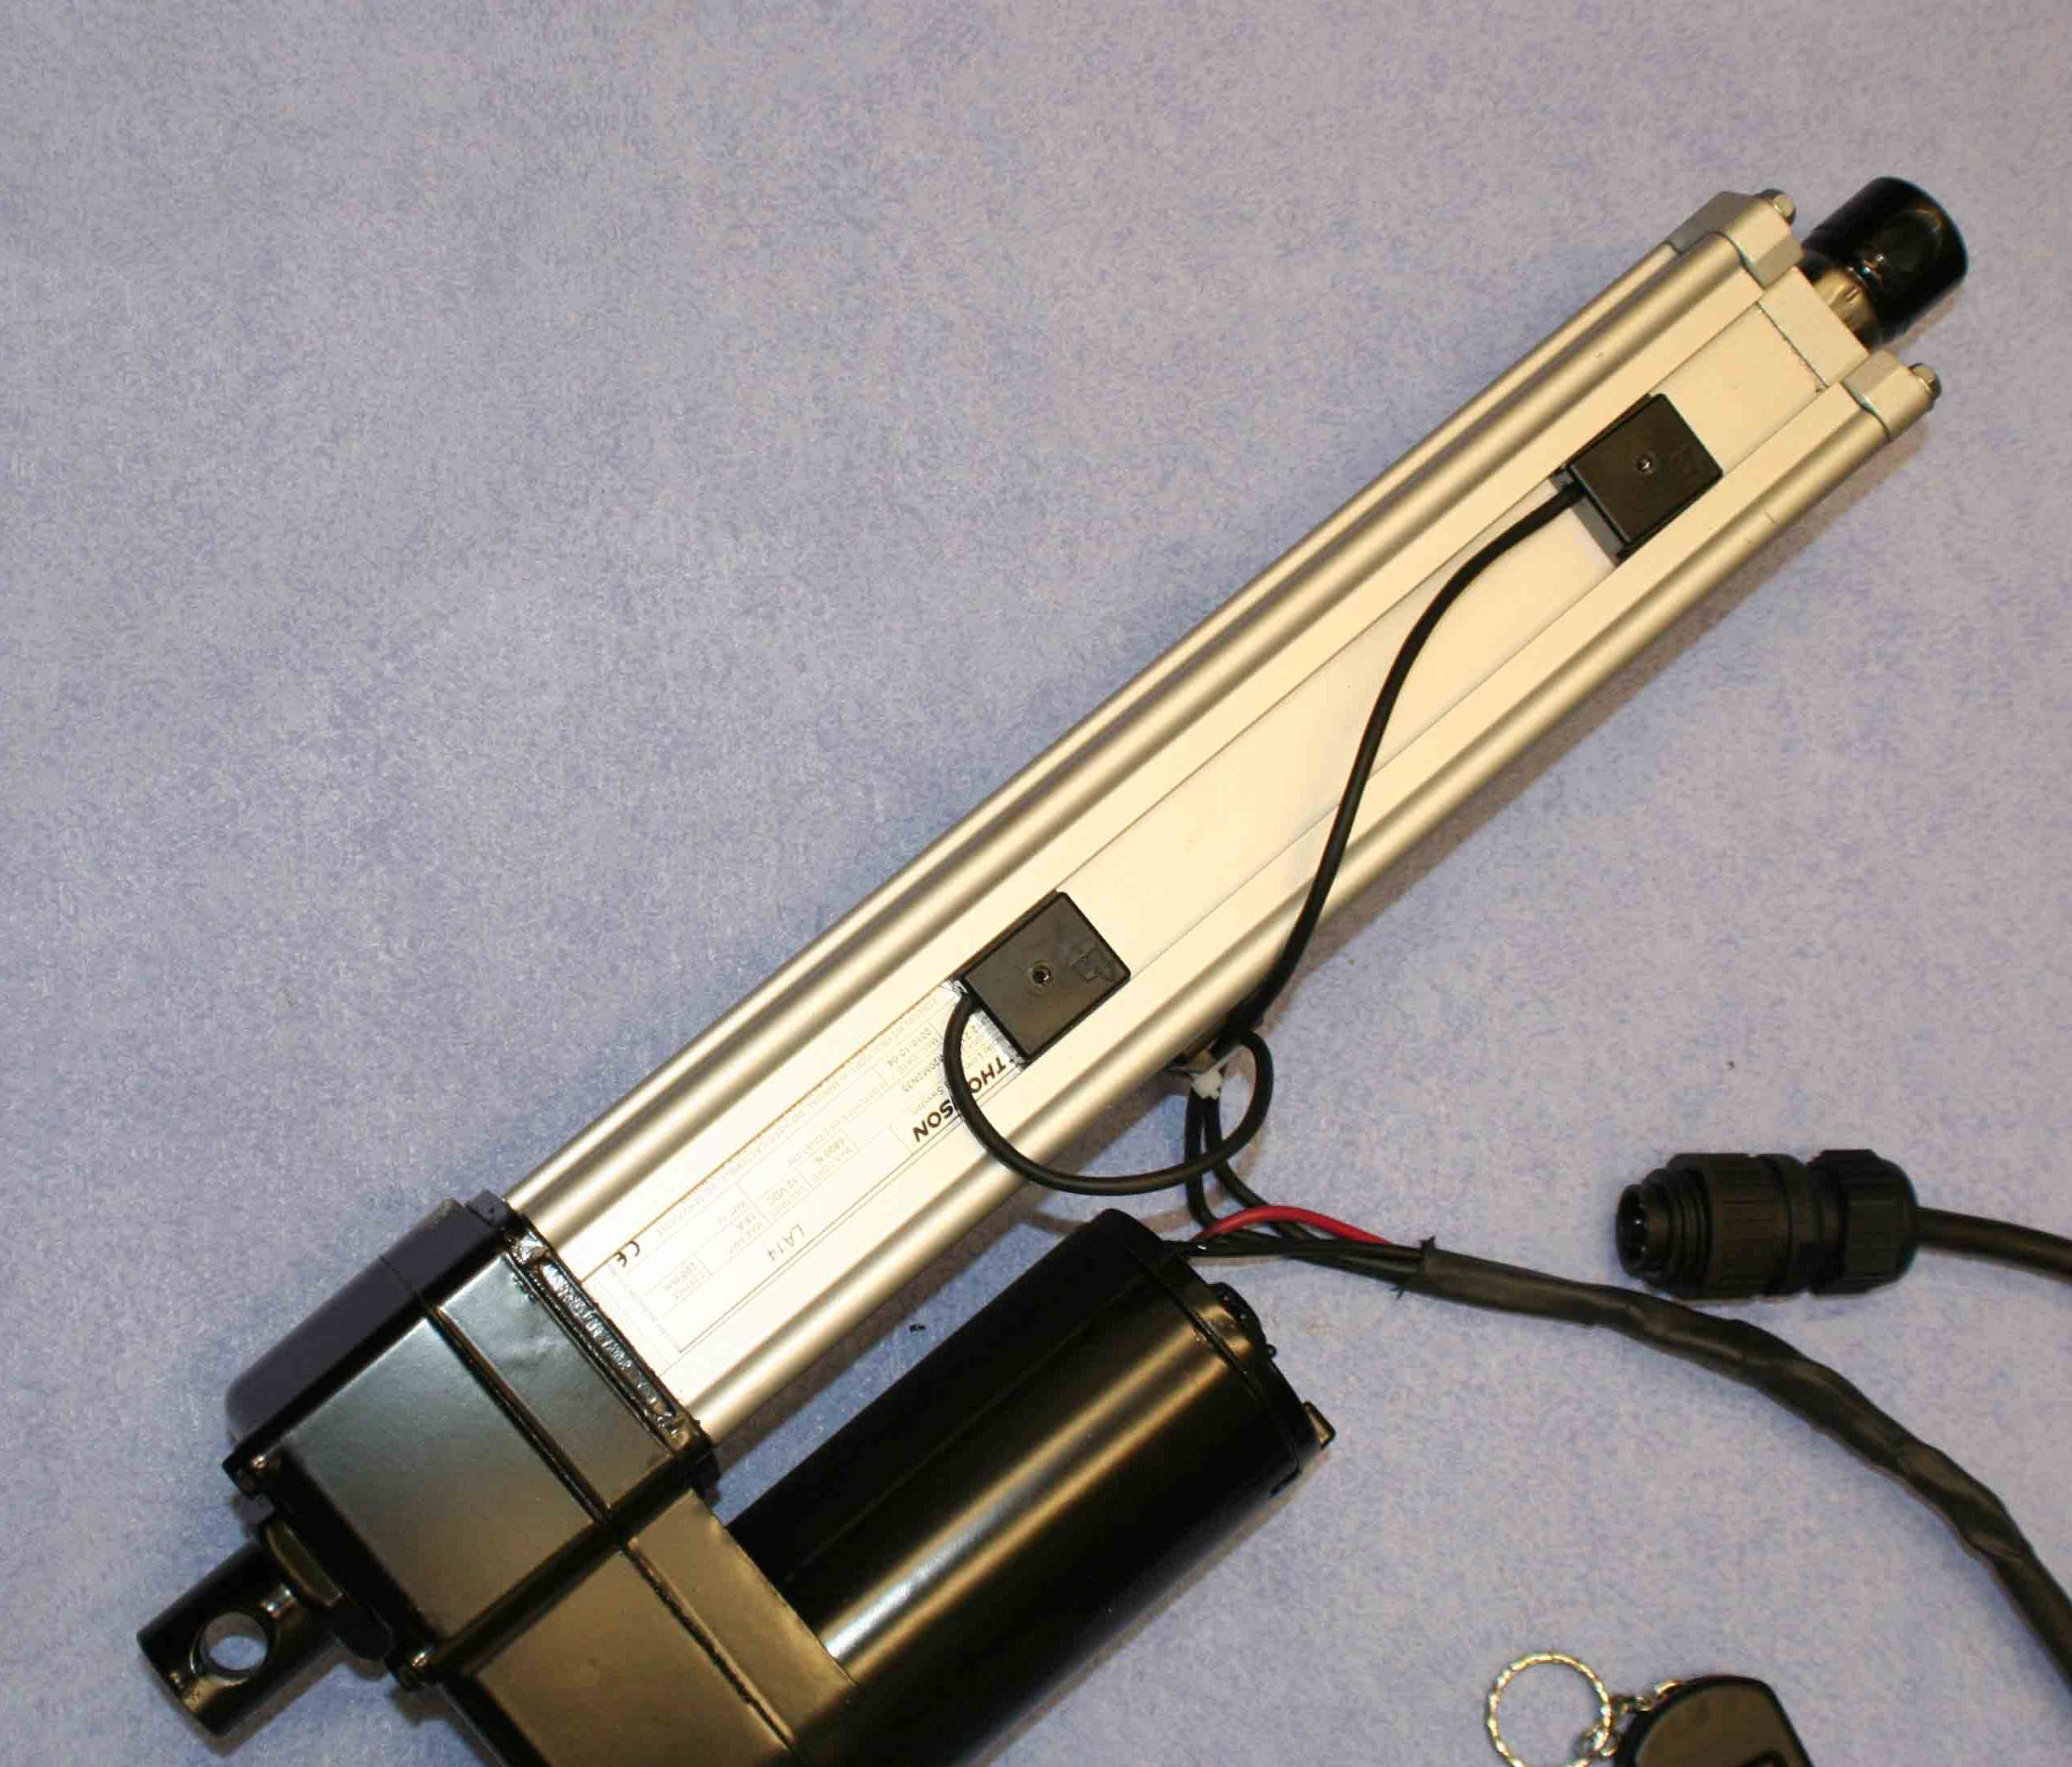

High Load LA14 Unit

Push and Pull of 680Kg load, adjustable limit switches. 12 volt dc motor.
Well suited to stronger heavier gates. Easier to fit as the adjustable limit switches allow for precise setting of end of stroke switch off.

Two brackets should be designed to locate the Actuator onto the gate.
For the La14 Actuator, Pivot pins of 12 mm should be used. Make sure the Actuator can freely rotate on the mount pins, sleeving may be a good option. Any stiffness may cause damage.

The Actuator has a maximum retract length of 670mm and maximum extend length of 1070mm.

Once an Actuator mount point has been set.

- In the close position measure a distance from the mount to the gate of 1060m and mark the gate.
- In the open position measure a distance from the mount to the gate of 680m and mark the gate.
- Fit the extension mount onto the gate between these points.

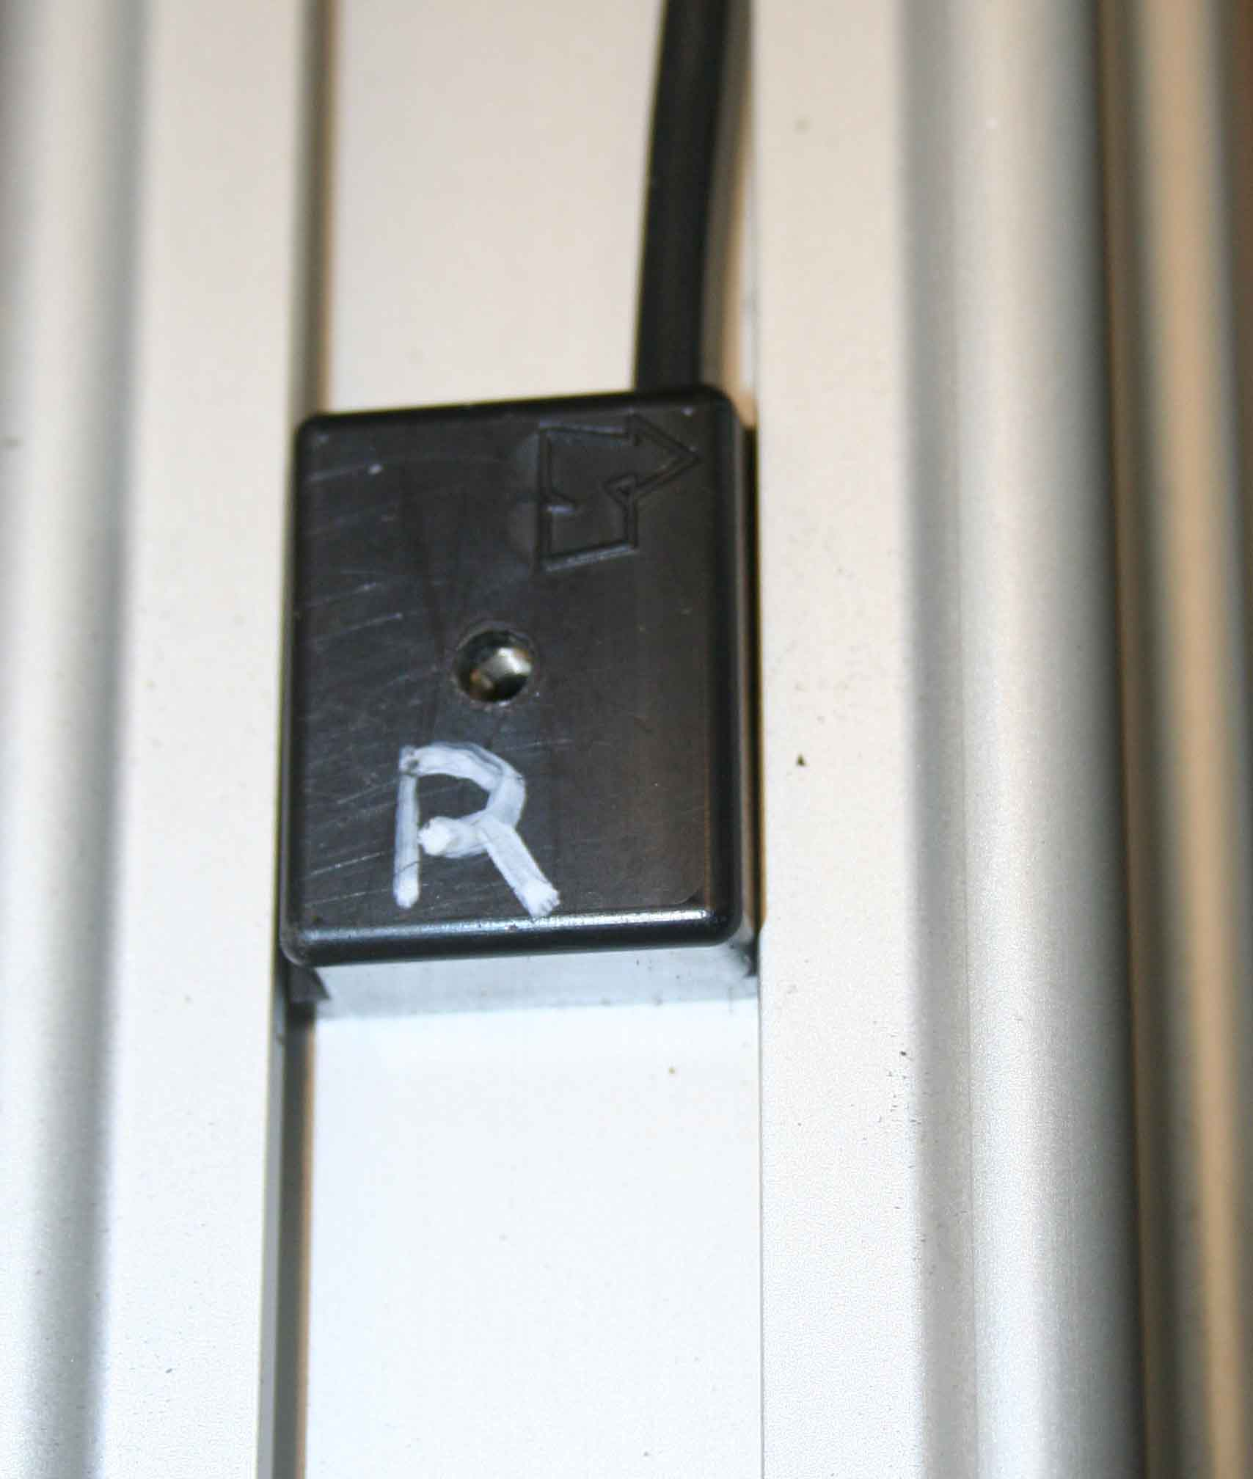
The stroke can be adjusted on the LA14 actuator by sliding the magnetic limit switches on the side of the Actuator. These are locked in place with a tiny grub screw, use the 1.5mm allen key provided.

Be careful not to adjust the limits beyond the mechanical limits of Actuator or system as this will cause the Actuator to clutch out.


Basic Set-Up and keyfob use.

Once you are happy with the location of the Actuator and the limits are set roughly correct the control box can be switched on by connecting the battery inside.

The dip switch on the circuit board should have number 1,2 and 3 switch set to off. This sets the control to direct switching not latched.
See Appendix

Pressing keyfob button 1 (left hand as above picture) will retract the ram, opening the gate and pressing button 11 (RH) will close the gate extending the ram. Releasing the button will stop the Actuator.

Once the Actuator is fitted the control can be switched using the handset to show the opening and close of the gate. The Battery supplied will switch the gate for a minimum of 20 operations before requiring charging, This allows for easier testing of the gate.

Open and close the gate a number of times, adjusting the limits and mounts to suit an accurate stopping point.

Mains Charger: Once the gate is operational, run the mains cable to the supply, always use an earth leakage circuit breaker with this unit. Be careful keeping all connections water tight , and possibly place the cable in an armoured sheath, if run underground.

Solar Panel Charger: Locate the solar panel facing south as out of shade as possible. Locate at an angle of approximately 45 degrees, do not place horizontally where water can sit on the panel. The charger will continually trickle charge the sealed lead acid battery. During periods of low light/ temperature and heavy use of the gate the battery may discharge. In which case occasionally top up charge with a regular mains car battery charger.

Operation Dip Switch Settings

There are 3 switchable modes for the unit:

Switch 1 and 2 off: (set-up build and test mode)

The control works in intermittent operation. The Linear Actuator will only move when the keyfob button is pressed. Releasing the button stops the Actuator.
This mode should always be used to set up the end positions on the Actuator. It also gives better control of the gate movement, if the gate is only required to open a little for pedestrian access, or if the user is worried about the gate opening with a vehicle, person or stock in the way.

Switch 1 on and Switch 2 off:

This is latched mode where a single press of either button will begin an open or close sequence. Button II (RH) on the handset pressed once will extend the Actuator and Close the gate, Button I (LH) on the handset pressed once will retract the Actuator and Open the gate.
This uses the limit switches built into the Actuator to switch off at end of stroke.
Once the gate is moving pressing either button again will stop the Actuator as emergency stop. Pressing 1 or 11 again will restart the open or close sequence.

Switch 1 on and Switch 2 on:

This is the Auto close mode.
Pressing button I (LH) will open the gate by retracting the Actuator, after a short time the gate will close automatically. Again pressing either button on the keyfob will act as emergency and stop the sequence.

The time between open and auto close is adjustable on the circuit using the small screw slot potentiometer. Fully Anti-Clockwise equates to 3 seconds delay and fully clockwise to 300 seconds delay.

The Auto-Retract feature has the increased possibility of hitting an object, the following options are available,

Loud Alarm Sounder
Flashing beacon
Through beam light sensor cut-offs.
Over load sensing of the Actuator motor.
Remote emergency stop buttons.

Switch 3

In latched and auto mode the system stops the linear actuator, using the limit switches on the unit. The control has no way of sensing it has reached end of stroke and continues to output a signal for the maximum time we expect the Actuator to run.

Switch 3 allows for two different times. In the off position this is set to 30 seconds for the LA14 and Pro-Series, set to on this has 16 seconds out for the E150 Actuator.

After this time the output is off and awaits the next input signal.

New designs may have the limit switch signal fed back to the box, which will override this time out.

Options – Remote Keyswitch.

The control has the option to be supplied with a Separate keyswitch for internal gate operation. A separate three-core cable should be run to the control box. And connected as per the wiring detail in the key switch box and battery control box.

Switch to Auto for normal operation.

Switch to locked fixes the Gate in that position, either closed or opened.

RF control is disabled as a security feature if the key switch is locked in either position.

Options - Overload Trip Circuit

This option offers current sensing to the Linear Actuator. If the gate should hit an object on its travel then the current will rise to stall levels. The control monitors this rise, switches the Actuator off then changes direction for 2 seconds. In effect if the gate is closing and hits an object the gate should stop and open slightly.

Please note the power of the Actuator will still be very high before sense levels, and therefore shouldn’t be used as a first level safety feature, more of a don’t damage my gate or car too uch feature.

Press the button twice to restart the Linear Actuator once the obstacle has been moved.

The level of current / load can be adjusted using the on circuit potentiometer. Anti-clockwise increases the current level, be careful when setting the level, keep to the minimum that will open and close the gate.

Options – Keypad

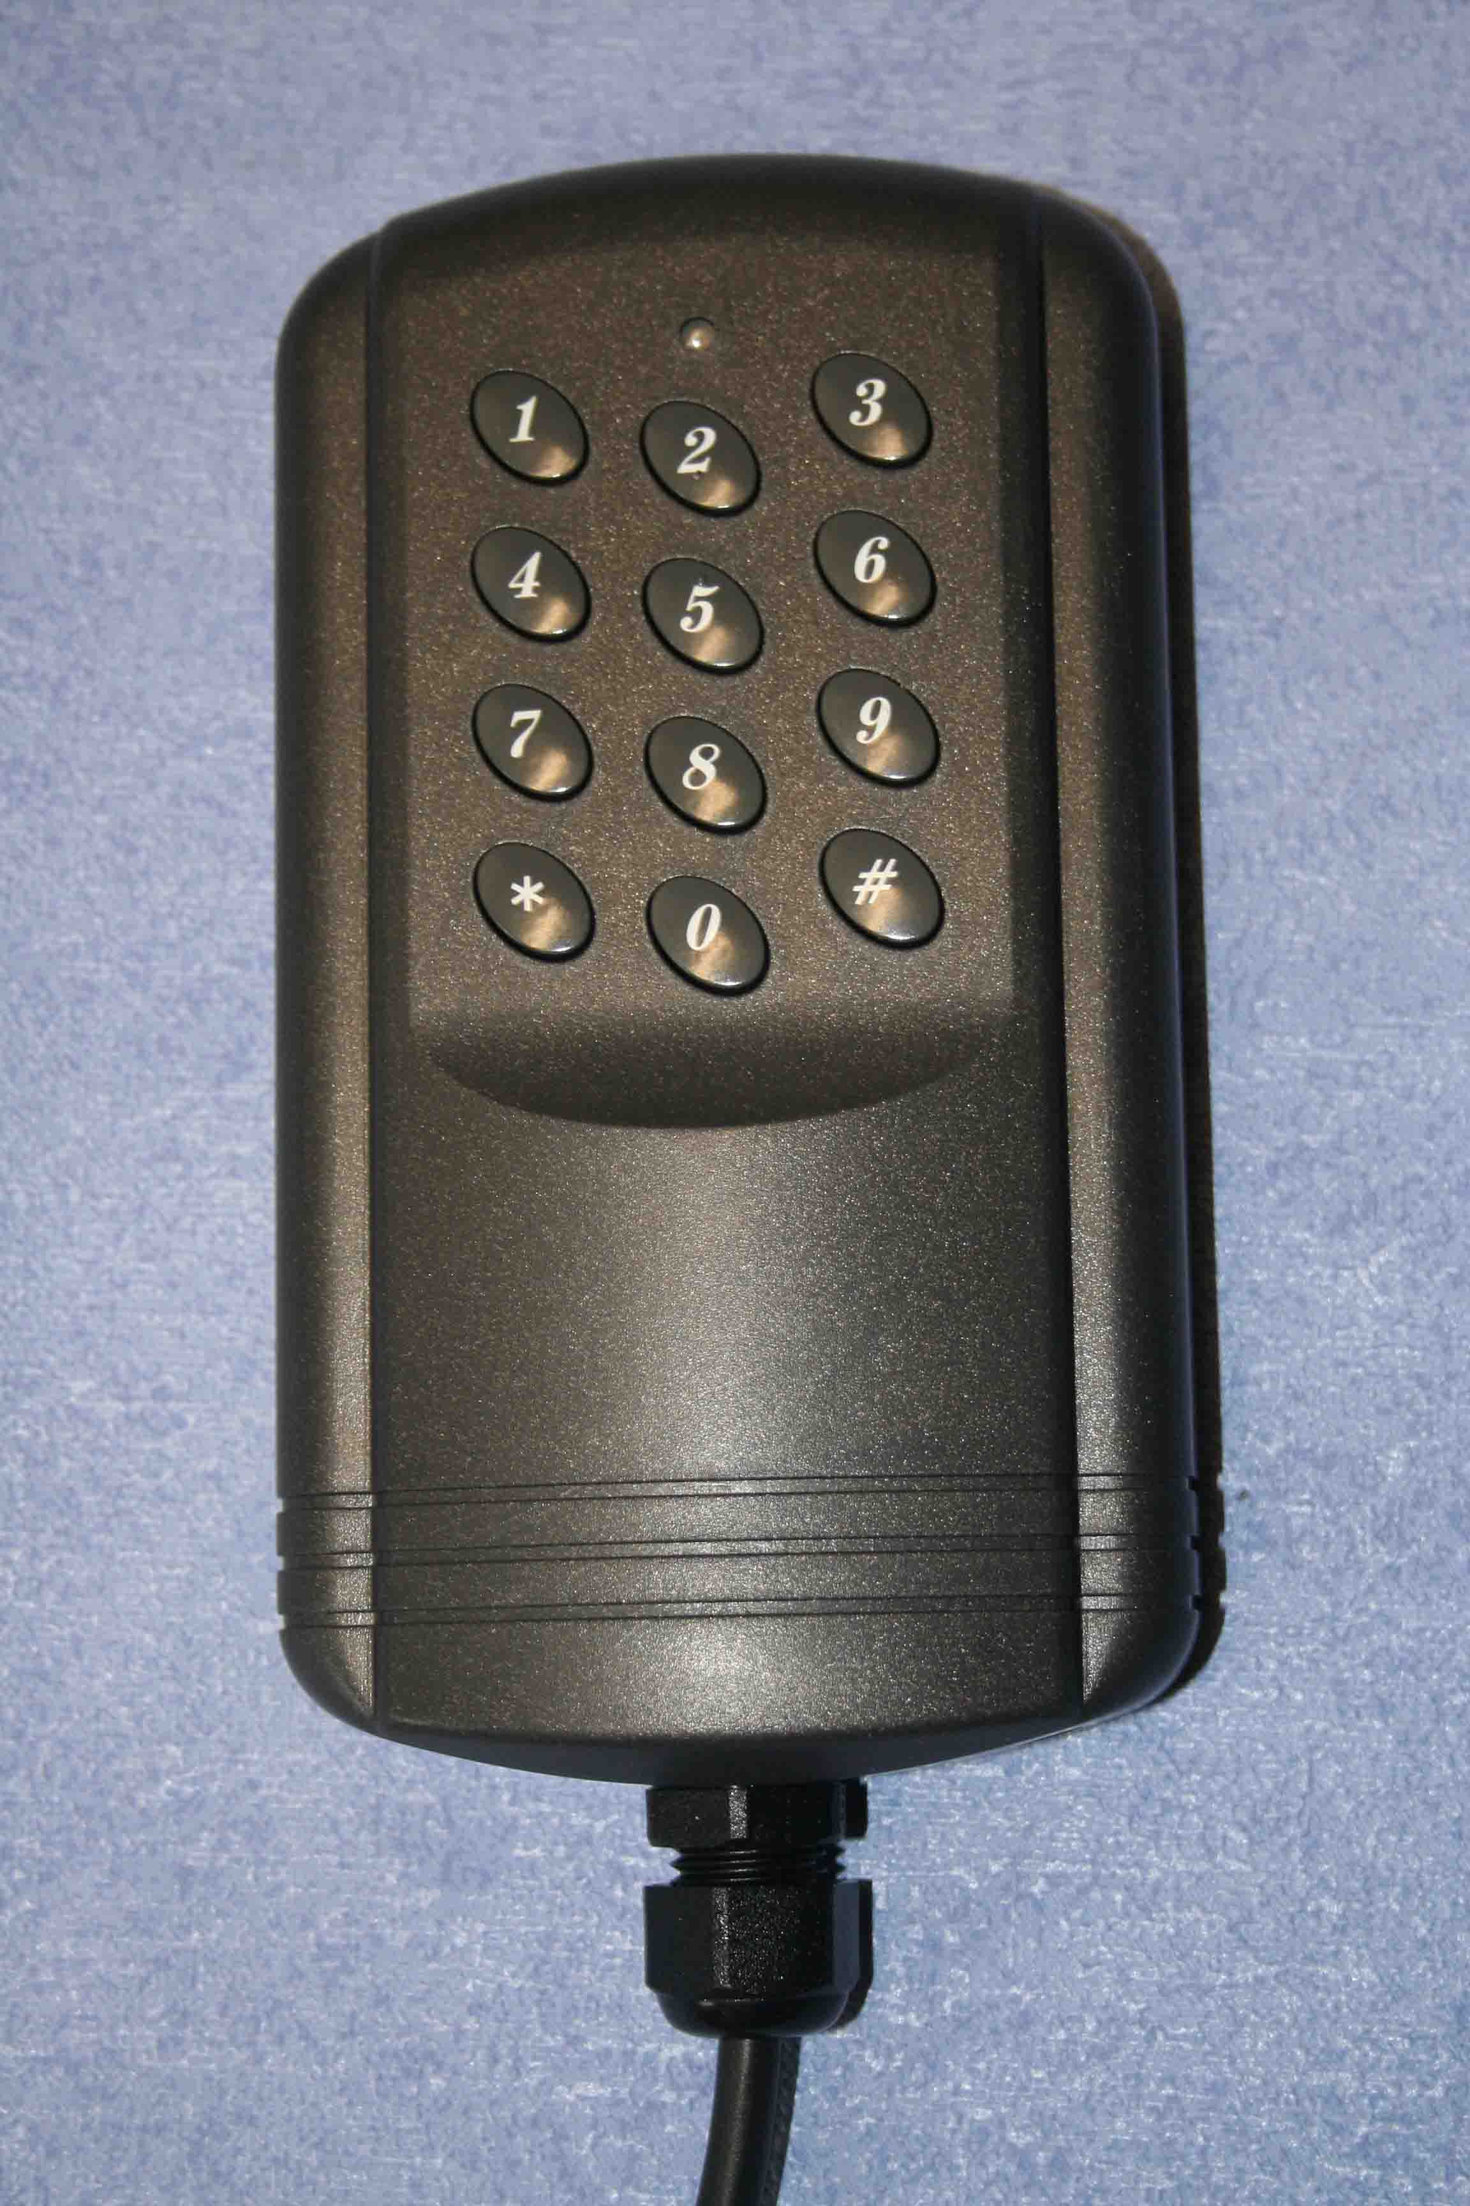

Instructions for the keypad are supplied separately with each keypad, these allow for a change of number to be pressed and the number of characters.

When the keypad is first delivered, we preset the number to a five digit code. This is written on the invoice, instructions and inside the control box.

These new keypads will only open the gate, therefore the gate needs to be set to Auto-Close latching before use, ie DIP switch 1 and 2 to on.

Easy and simple to use just press the 5 digit code and the gate will open.

The Gate can be stopped, by pressing the code again, or pressing a keyfob button.

The keypad is a sealed unit but is best mounted under some rain cover for longer life.

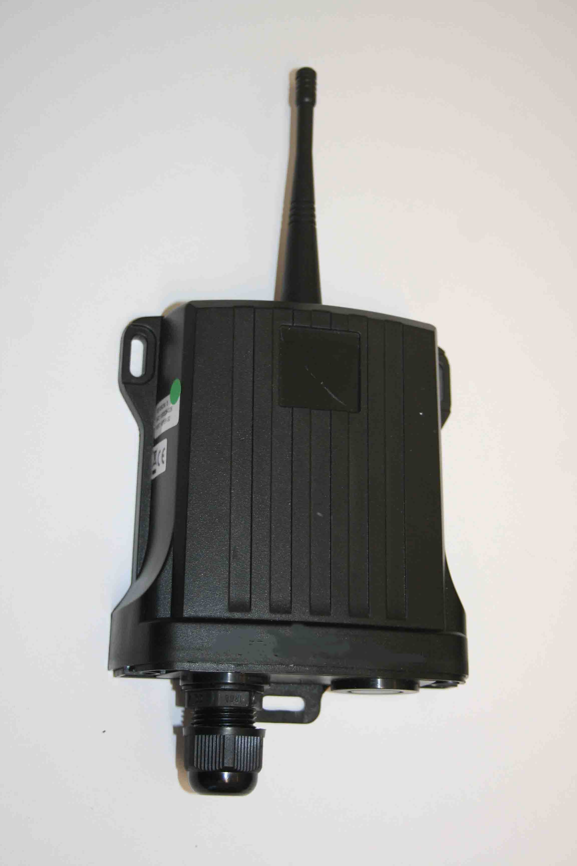

Telephone Call to Open

When the keypad is first delivered, we have loaded it with a SIM card which has a preset number. There should be no charge to make a call and no charge to keep the SIM alive, although things may change with the providers.

The number a standard mobile telephone number is written on the invoice, instructions and inside the control box.

These new telephone call to open will only open the gate, therefore the gate needs to be set to Auto-Close latching before use, ie DIP switch 1 and 2 to on.

Easy and simple to use just dial the gate and the gate will put the phone down on you and the gate will open.

The Gate can be stopped, by dialling the number again, or pressing a keyfob button.

The circuit is usually supplied within the battery control box, but in certain circumstances of poor reception the circuit may be supplied as above or with a separate antenna.

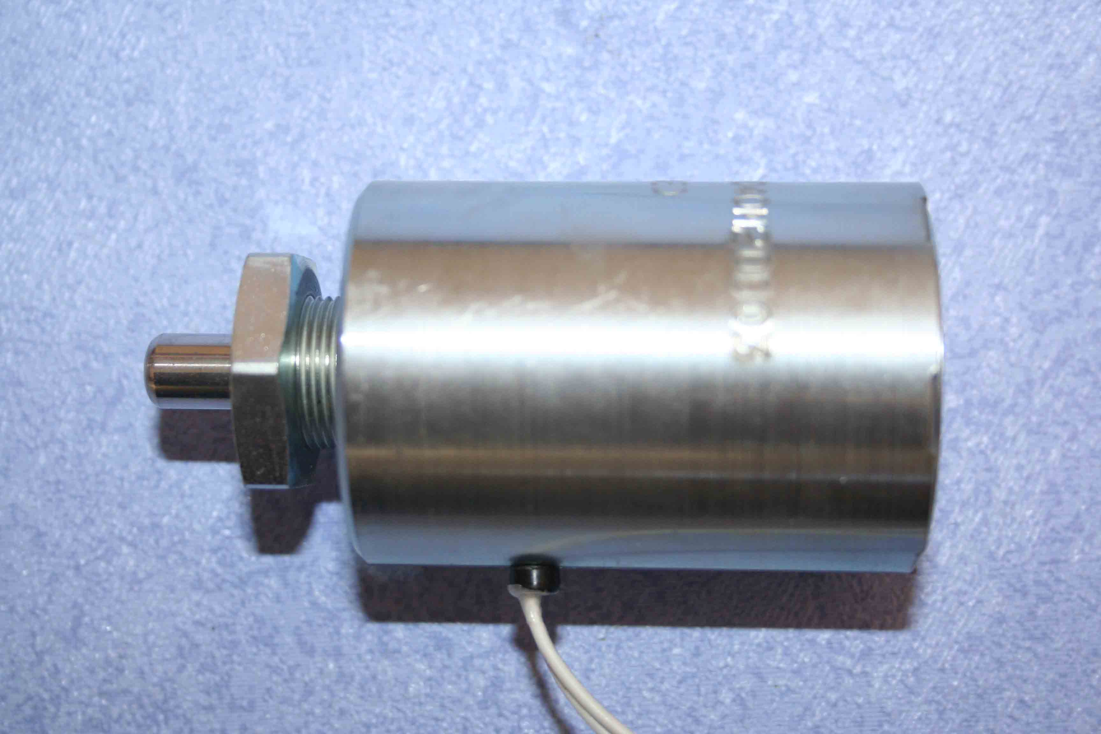
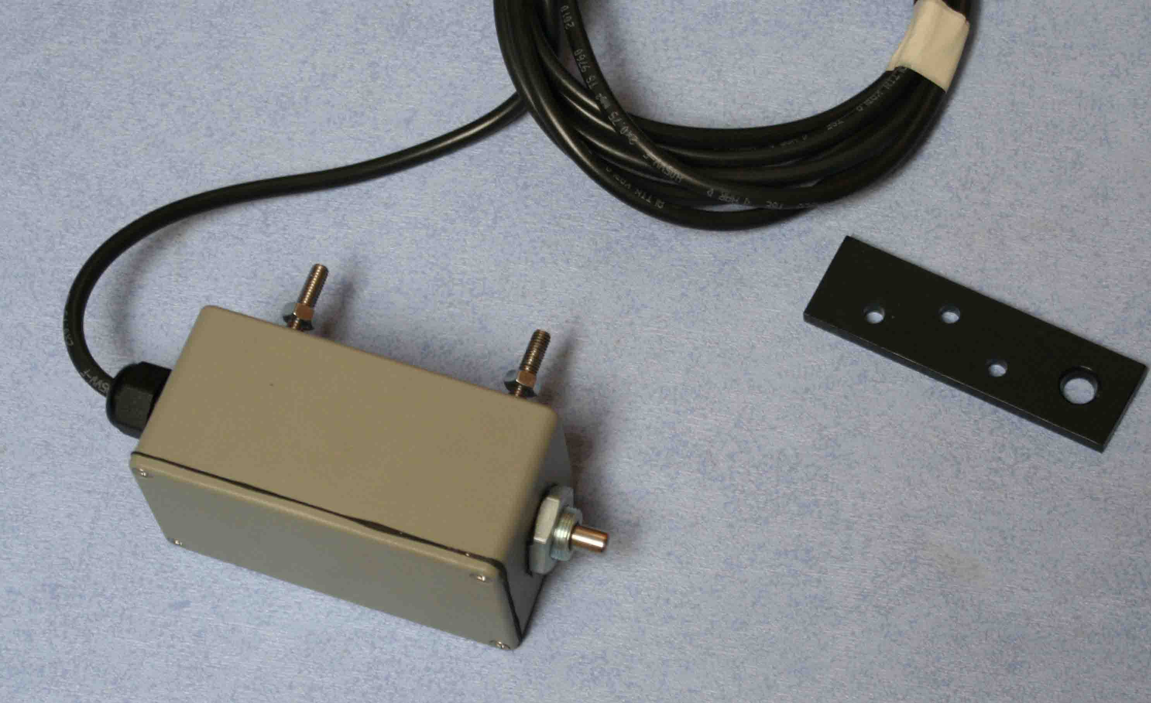

Option – Solenoid Lock

The solenoid lock is supplied to locate the gate in the open or closed position. The 10mm pin will retract whenever the Actuator moves and spring out when the Actuator stops. It is supplied with a steel strike plate.

The solenoid can be used to lock the gate in the open or closed position, or both. Mount the unit on the gate using the two holes and supplied self tapper screws, then locate the strike plate in the end post.

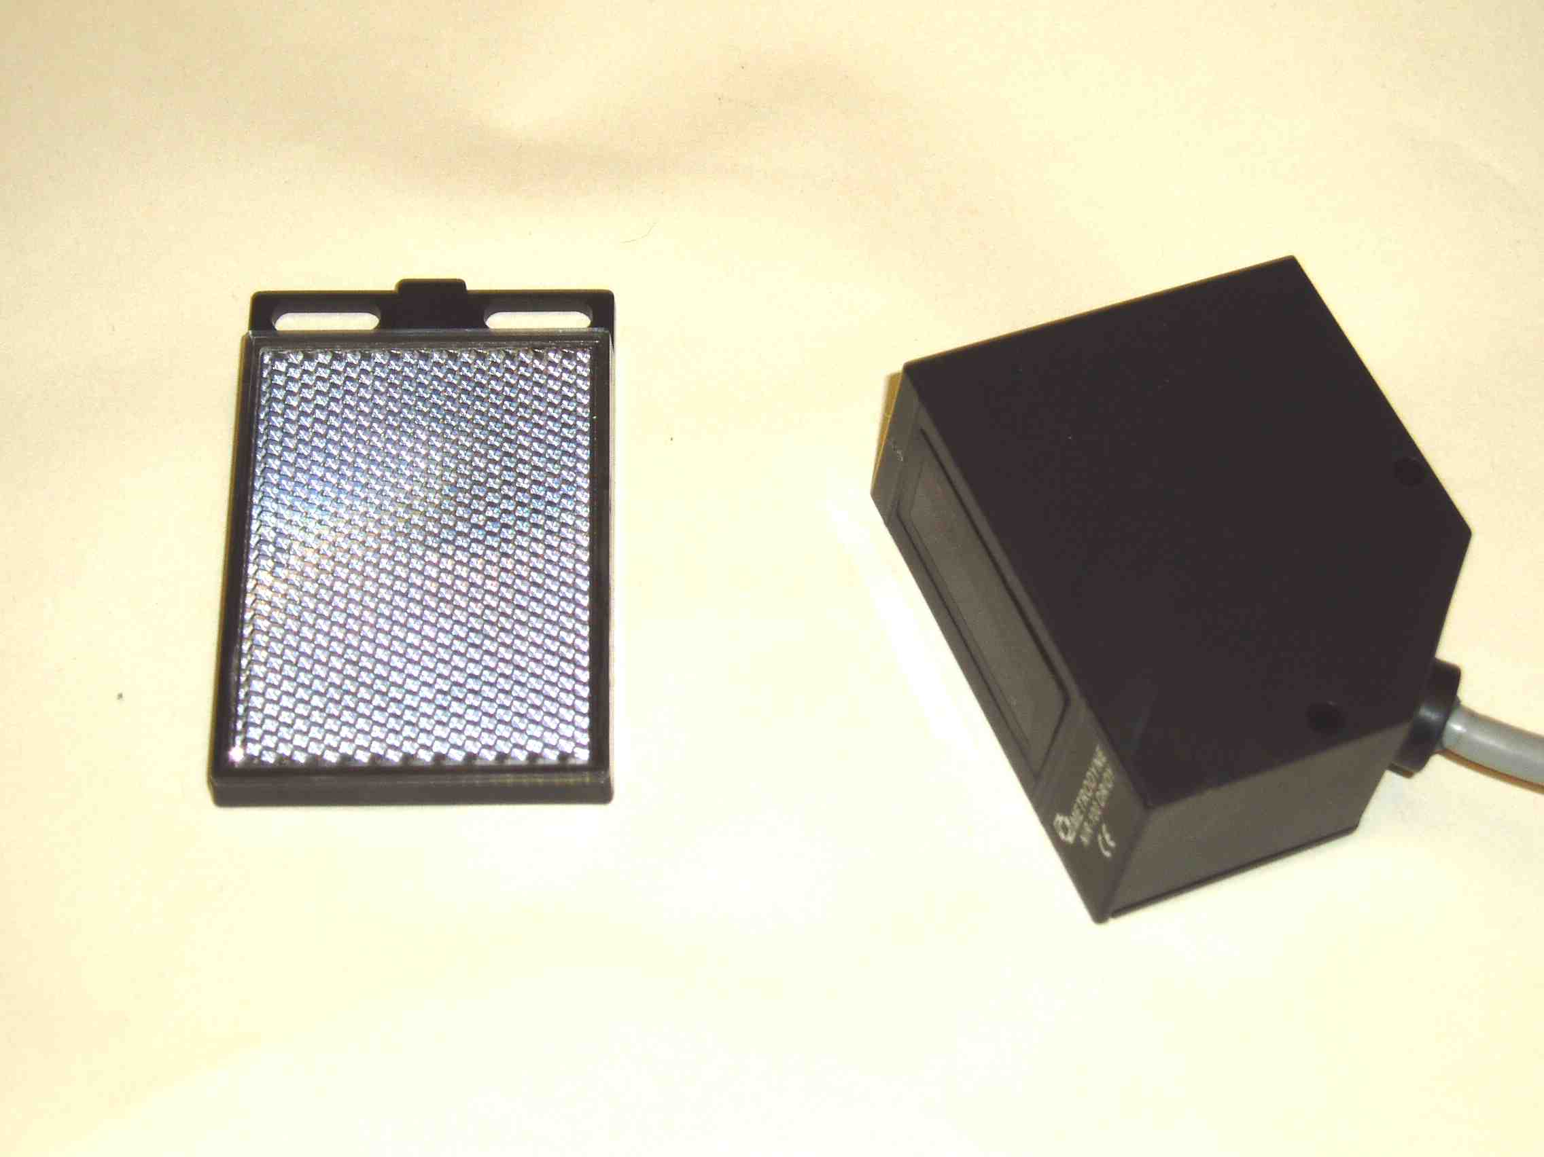

Option - Light Beam Sensors

The light beam sensors will stop all Actuator movement whilst the beam is broken.

Align one sensor across the driveway at the hinge posts and the other just out of rear of the moving gate to give best coverage for the moving gate. Remember not to allow the gate to break the beam.

The maximum distance is 7 metres.

With the red power wire in the permanent supply on the circuit it should be relatively simple to line up the light and check the red led is illuminated on the transmitter. Once lit the led should go out when the beam is broken.

The light beam only works with the Auto-Close mode so switch DIP 1 and 2 to on, and turn the wait time down low. Press the gate open keyfob button. The gate should open and close as expected.

Do the test again but this time break the beam to check it switches off. Restart by pressing any keyfob button to open or close.

Test each of the sensors in turn and check for alignment/ height problems.

SOLAR. Once the beams have beam tested satisfactorily move the position of the red wire on the circuit. This stops the sensors draining the battery and only allows there operation when the Actuator is moving. This is not a problem for mains powered gates.

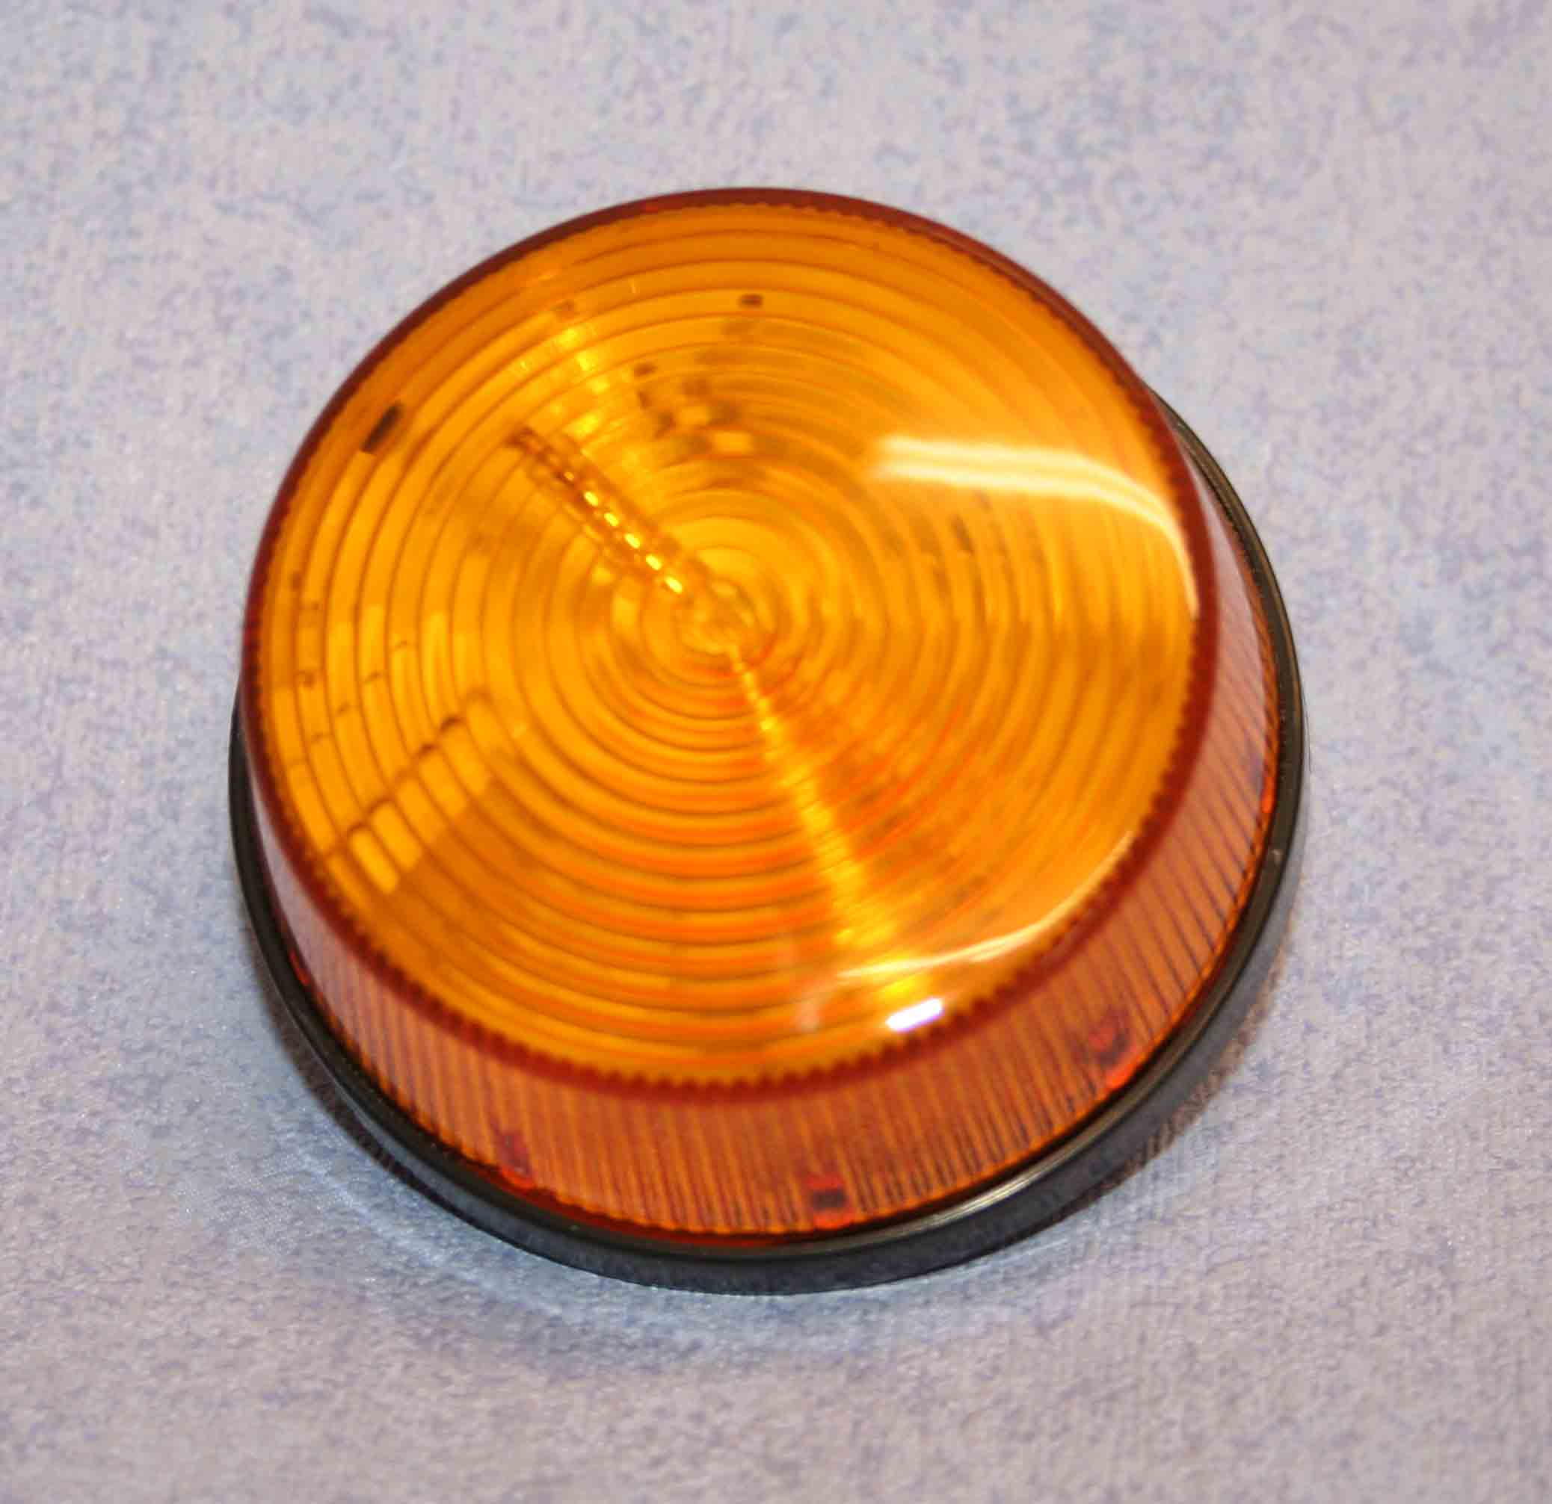

Option - Beacon/Buzzer

Locate the beacon and buzzer unit on top of the gate post.
Every time the linear actuator moves the beacon will flash and alarm sound

Hollin Applications Ltd. accepts no responsibility for incorrect mounting and use of this system.
All parts are covered by our 1 year return to base warranty.

The Station
Wolsingham
Weardale
Co. Durham
DL13 3BL
Tel. (44) 01388 529000
www.hollinapplications.co.uk



HOL1-DWG6-016 Version 5 July 2013

